

**PROGRAMME TITLE: EBRD UNCITRAL Public Procurement Reform Initiative**

**PROJECT TITLE: Moldova: Assistance with Piloting Electronic Framework Agreements on MTender**

**FRAMEWORK AGREEMENT PROCESSES, TECHNICAL DESIGN AND DATA MODEL**

February 2021

Approval page

|  |  |
| --- | --- |
| **Client Name** | EBRD |
| **Project** | Moldova: Assistance with Piloting Electronic Framework Agreements on MTender |
| **Date of delivery** | 15.05.2020 |
| **Date of submission for Acceptance** |  |

|  |  |  |
| --- | --- | --- |
| **The output is specified in the table below and includes a list of delivered deliverables.**  **The output is in accordance with approved specifications and complies with all conditions defined in the Contract, as per the Terms of Reference.** | | |
| **Deliverable** | **Deliverable Description** | **Acceptance Date** |
| Deliverable 2 | Framework agreement processes, technical design and data model |  |
| **All deliverables were prepared in required quality and time and are accepted without open points.**  **Other comments** | | |

|  |  |  |
| --- | --- | --- |
| **Person responsible for Delivery** | Signature: | Date:__________ |
| everis |  |
| **Persons responsible for Sign-off** | Signature: | Date: ___________ |
| Eliza Niewiadomska  Senior Counsel  Legal Transition Programme  European Bank for Reconstruction and Development |  |
|  | Signature: | Date: ___________ |

*Please be advised that the deliverables have been prepared exclusively for the EBRD. The EBRD makes no representation or warranty, express or implied, as to the accuracy or completeness of the information set forth in this report. EBRD has not independently verified any of the information contained in the report and EBRD accepts no liability whatsoever for any of the information contained in the report or for any misstatement or omission therein. The report remains EBRD’s property.*

Document characteristics

|  |  |
| --- | --- |
| **Property** | **Value Proposition** |
| Release date | *15/05/2020* |
| Status: | *Pending approval* |
| Version: | *V4.0* |
| Authors: | *everis* |
| Reviewed by: | *Chris Smith, Andrei Rogac and Eriks Mezalis* |
| Approved by: |  |

Document history

|  |  |  |
| --- | --- | --- |
| **Version** | **Description** | **Date** |
| 1.0 | *Preparation of Technical Design - Revision of framework agreement processes and data model in order to validate compliance with the EU Directives on Public Procurement and alignment with the eProcurement Ontology* | *15.05.2020* |
| 2.0 | *Updated draft incorporating reviewers’ comments*  *Further version will be produced by everis when outstanding information has been provided.* | *6.06.2020* |
| 3.0 | *Updated draft with complete information* | *15.10.2020* |
| 4.0 | *New approach: high-level definition for framework agreements (regarding processes, technical design and data model)* | *26/02/2021* |

List of abbreviations

|  |  |
| --- | --- |
| AB | Aggregated Budget |
| AP | Aggregated Plan |
| BPMN | Business Process Model Notation |
| CA | Contracting Authority |
| CAN | Contract Award Notice |
| CN | Contract Notice |
| CPB | Central Purchasing Body |
| CP | Contracting Process |
| CPV | Common Procurement Vocabulary |
| eAuction | Electronic Auction |
| EBRD | European Bank for Reconstruction and Development |
| eCatalogue | Electronic Catalogue |
| EI | Expenditure Item |
| EO | Economic Operator |
| EoI | Expression of Interest |
| eProcurement | Electronic Procurement |
| EU | European Union |
| EUPD | European Union Procurement Directives |
| FA | Framework Agreement |
| FE | Framework Establishment |
| FS | Funding Source |
| GPA | World Trade Organization Government Procurement Agreement |
| MC | Mini-competition |
| MEAT | Most Economically Advantageous Tender |
| NEPP | Networking Electronic Procurement Platform |
| OCDPS | Open Contracting Digital Procurement System |
| OCDS | Open Contracting Data Standard |
| PAC | Pre-award Catalogue |
| PC | Purchase Contract |
| PCR | Pre-award Catalogue Request |
| PIN | Prior Information Notice |
| PO | Purchase Order |
| PN | Periodic Notice |
| PQ | Pre-qualification |
| PQC | Pre-qualification Criteria |
| PR | Purchase Request |
| RfPQ | Request for Price Quotation |
| RfQ | Request for Quotation |
| SS | Selected Suppliers |
| UML | Unified Modelling Language |
| UNCITRAL | United Nations Commission on International Trade Law |
| VAT | Value-Added Tax |

GLOSSARY

| **Term** | **Definition*[1]*** |
| --- | --- |
| Framework agreement procedure | A procedure conducted in two stages: a first stage to select a supplier (or suppliers) or a contractor (or contractors) to be a party (or parties) to a framework agreement with a procuring entity, and a second stage to award a procurement contract under the framework agreement to a supplier or contractor party to the framework agreement. |
| Framework agreement | An agreement between the procuring entity and the selected supplier (or suppliers) or contractor (or contractors) concluded upon completion of the first stage of the framework agreement procedure. |
| Closed framework agreement | A framework agreement to which no supplier or contractor that is not initially a party to the framework agreement may subsequently become a party. |
| Open framework agreement | A framework agreement to which a supplier (or suppliers) or a contractor (or contractors) in addition to the initial parties may subsequently become a party or parties. |
| Framework agreement procedure with second-stage competition | A procedure under an open framework agreement or a closed framework agreement with more than one supplier or contractor in which certain terms and conditions of the procurement that cannot be established with sufficient precision when the framework agreement is concluded are to be established or refined through a second-stage competition. |
| Framework agreement procedure without second-stage competition | A procedure under a closed framework agreement in which all terms and conditions of the procurement are established when the framework agreement is concluded. |

*NOTES*:

* Procuring entities are called contracting authorities in the EU Directives on Public Procurement (EUPD) and in Moldova’s regulation.
* The concepts of “Open framework agreement” and “Closed framework agreement” do not exist in the EU Directives on Public Procurement (EUPD), where the set of selected suppliers is always determined with the conclusion of the framework agreement and no new suppliers can be added to the initial parties subsequently. As is stated in the EUPD: *“(…) a framework agreement should not be open to entry of new economic operators once it has been concluded”.*

Therefore, under the EUPD, all framework agreements are actually “Closed framework agreements”, and the “Open framework agreement” is foreseen as a “Dynamic Purchasing System”.

* In Moldova, “Open framework agreement” is called Dynamic Purchasing System, as it is in the EUPD.
* Although UNCITRAL states that new contractors can join an open framework agreement, this is not contemplated in EUPD for Dynamic Purchasing Systems.

Table of Contents

1 About this document 14

Aim of the document 14

Who is this document for? 14

2 Introduction to Framework Agreements 15

3 Framework agreement processes 16

3.1 Framework agreement conclusion 16

3.2 Contracts based on a framework agreement 17

Direct purchase 18

Second-stage competition 19

Request for price quotation 21

4 Framework agreement technical design 21

4.1 Basic concept of a FA with the participation of a CPB 21

Main data blocks 22

Main actors 23

Data flow 24

4.2 OCDS design 25

Map of relations 27

OCDS parallel records used to reflect OCDS design for FAs 28

4.3 Conclusion of a FA 34

Initiation of a FA 35

Aggregated planning 36

Design of a FA 37

Conclusion of a FA 49

Pre-award catalogue request 65

4.4 Execution of a FA 77

State-chart diagrams 78

OCDS dataset 79

OCDS dataflow 80

5 Framework agreement data model 101

5.1 Framework agreement 101

Diagram 101

Class description and relationship with OCDS 102

5.2 Funding Source 104

Diagram 104

Class description and relationship with OCDS 104

5.3 Expenditure item 106

Diagram 106

Class description and relationship with OCDS 106

5.4 Contracting process 108

Diagram 108

Class description and relationship with OCDS 109

5.5 Periodic notice 111

Diagram 111

Class description and relationship with OCDS 112

5.6 Mini Competition 113

Diagram 113

Class description and relationship with OCDS 114

5.7 Purchase contract 115

Diagram 115

Class description and relationship with OCDS 116

5.8 Pre-Qualification 117

Diagram 117

Class description and relationship with OCDS 118

5.9 Pre-Award Catalogue 119

Diagram 119

Class description and relationship with OCDS 120

5.10 Aggregated Plan 121

Class description and relationship with OCDS 121

5.11 Framework Establishment 122

Class description and relationship with OCDS 123

5.12 Pre-qualification Criteria 123

Class description and relationship with OCDS 124

List of figures

Figure 1. BPMN for the general process of a FA 17

Figure 2. Framework Agreement Execution 17

Figure 3. Direct purchase under a framework agreement 18

Figure 4. Second-stage competition under a framework agreement 19

Figure 5. Request for price quotation under a framework agreement 21

Figure 6 - Basic diagram of a FA with the participation of a CPB 22

Figure 7 – OCDS design for a FA 26

Figure 8 - BPMN for initiation of a FA 35

Figure 9 - BPMN for aggregated planning 36

Figure 10 – Component diagram for aggregated planning 36

Figure 11 – Simplest case 38

Figure 12 – Complex case 38

Figure 13 – Simplest case 42

Figure 14 – Division into lots 43

Figure 15 – Options for additional purchases 43

Figure 16 – Renewals 44

Figure 17 – Variants 44

Figure 18 – Duration of the FA 45

Figure 19 – Limitation on the number of candidates at tender level 45

Figure 20 – Limitation on the number of candidates at lot level 45

Figure 21 – Other criteria 46

Figure 22 – Award criteria 47

Figure 23 – Criteria 48

Figure 24 – Conversions 49

Figure 25 – State-chart diagram for the conclusion of a FA 49

Figure 26 – Enquiry period 50

Figure 27 – PreQualification 50

Figure 28 – Period for submission of EoIs 51

Figure 29 – Enquiries 51

Figure 30 – Answers to enquiries 52

Figure 31 – Submission of EoI 53

Figure 32 – State-chart diagram for submission of EoIs 53

Figure 33 – Status of the tender 54

Figure 34 – Status of the preQualification 54

Figure 35 – Unsuccessful status at lot level 54

Figure 36 – Unsuccessful status at tender level 55

Figure 37 – Disculosure of submissions 56

Figure 38 – Period for Qualification 56

Figure 39 – Status of the Qualification 56

Figure 40 – State-chart diagram for Qualification 57

Figure 41 – Request of declaration 58

Figure 42 – Declaration 59

Figure 43 – Qualification of submissions 60

Figure 44 – Qualification period 61

Figure 45 – PreQualification status 62

Figure 46 –Qualification period 62

Figure 47 –PreQualification status 63

Figure 48 –Unsuccessful outcome at lot level 63

Figure 49 –Unsuccessful outcome at tender level 63

Figure 50 –Conclusion of a FA 64

Figure 51 –Scope of the FA 65

Figure 52 –Successful outcome at lot level 65

Figure 53 –Successful outcome at tender level 65

Figure 54 – State-chart diagram for a PAC request 66

Figure 55 – Enquiry period 67

Figure 56 – Tender period 67

Figure 57 – Bid information 68

Figure 58 – Unsuccessful lot 69

Figure 59 – Unsuccessful tender 69

Figure 60 – Disclosure of bids 70

Figure 61 – Award period 70

Figure 62 – Evaluation 71

Figure 63 – Awards 73

Figure 64 – Contracts 74

Figure 65 – Cancelled contract 74

Figure 66 – Unsuccessful contract 75

Figure 67 – Status “Pending” 75

Figure 68 – Contract initiation 76

Figure 69 – Unsuccessful lot 76

Figure 70 – Unsuccessful tender 77

Figure 71 – Successful lot 77

Figure 72 – Successful tender 77

Figure 73 – State-chart diagram for direct purchase under a FA 78

Figure 74 – State-chart diagram for mini-competition under a FA 78

Figure 75 – Code for issuing of a Direct purchase under a FA 79

Figure 76 – Code for issuing a Mini-competition under a FA 80

Figure 77 – Code for establishing the period of a Purchase request 81

Figure 78 – Code for information of a bid 82

Figure 79 – Code for unsuccessful outcome of procurement initiation at lot level 82

Figure 80 – Code for unsuccessful outcome of procurement initiation at tender level 83

Figure 81 – Code for quotation information 84

Figure 82 – Code for period for evaluation 84

Figure 83 – Code for evaluation of envelopes 85

Figure 84 – Code for award details 86

Figure 85 – Code for award decision 86

Figure 86 – Code for cancellation of the award decision 87

Figure 87 – Code negative award decision 87

Figure 88 – Code for positive award decision 88

Figure 89 – Code for contract initiation 88

Figure 90 –Code for closure of the evaluation phase 89

Figure 91 – Code for unsuccessful lot 89

Figure 92 – Code for unsuccessful procurement initiation 90

Figure 93 – Code for successful lot 90

Figure 94 – Code for successful procurement initiation 90

Figure 95 – Code for establishing the period for Call for proposals 91

Figure 96 – Code for bid information 92

Figure 97 – Code for unsuccessful lot 92

Figure 98 – Code for unsuccessful purchase request 93

Figure 99 – Code for tender information 93

Figure 100 – Code for evaluation period 94

Figure 101 – Code for evaluation of envelopes 94

Figure 102 – Code for award information 96

Figure 103 – Code for award decision 97

Figure 104 – Code for cancellation of award decision 97

Figure 105 – Code for confirmation of award decision 97

Figure 106 – Code for positive award decision 98

Figure 107 – Code for contract initiation 98

Figure 108 – Code for closure of the evaluation phase 99

Figure 109 – Code for unsuccessful outcome of procurement initiation at lot level 99

Figure 110 – Code for unsuccessful outcome of procurement initiation at tender level 99

Figure 111 – Code for successful outcome of procurement initiation at lot level 100

Figure 112 – Code for successful outcome of procurement initiation at tender level 100

Figure 113. Framework Agreement 101

Figure 114. Funding Source 104

Figure 115. Expenditure Item 106

Figure 116. Contracting process 108

Figure 117. Periodic notice 111

Figure 118. Mini Competition 113

Figure 119. Purchase Contract 116

Figure 120. Pre-Qualification 118

Figure 121. Pre-Award Catalogue 120

List of Tables

Table 1 – Main data blocks involved in a FA 23

Table 2 – Main actors involved in a FA 23

Table 3 – Main actors involved in a FA 25

Table 4 – Map of relations 28

Table 5 – Attributes of EI 28

Table 6 – Attributes of FS 29

Table 7 – Attributes of CP 30

Table 8 – Attributes of PN 30

Table 9 – Attributes of MC 31

Table 10 – Attributes of PC 31

Table 11 – Attributes of FA 32

Table 12 – Attributes of AP 32

Table 13 – Attributes of FE 32

Table 14 – Attributes of PQ 33

Table 15 – Attributes of PQC 33

Table 16 – Attributes of PAC 34

Table 17 - OCDS blocks involved in the conclusion of a FA 34

Table 18 – Award criteria 71

Table 19 – Automated and manual award criteria depending on the ranking approach 94

Table 20. Attributes of the “Framework Agreement” class 103

Table 21. Attributes of the “Funding Source” class 106

Table 22. Attributes of the “Expenditure item” class 108

Table 23. Attributes of the “Contracting process” class 111

Table 24. Attributes of the “Periodic notice” class 112

Table 25. Attributes of the “Mini Competition” class 115

Table 26. Attributes of the “Purchase contract” class 117

Table 27. Attributes of the “Pre-Qualification” class 119

Table 28. Attributes of the “Pre-Award Catalogue” class 121

Table 29. Attributes of the “Aggregated Plan” class 122

Table 30. Attributes of the “Framework Establishment” class 123

Table 31. Attributes of the “Pre-qualification Criteria” class 124

# About this document

## Aim of the document

The European Bank for Reconstruction and Development (EBRD or the Bank) UNCITRAL Initiative is aimed at digital transformation of public procurement through the implementation of a new eProcurement model branded as Open Contracting Digital Procurement System (OCDPS).

OCDPS is a new eProcurement model that is being implemented by the Bank UNCITRAL Initiative in the context of digital transformation of public procurement.

The OCDPS meets most of the recommendations and best practices identified in existing policy-making documents and comparative practice in the European Union and other international standards, and it has already been highlighted as a major development globally. It also guarantees compliance with international legal frameworks such as the UNCITRAL Model Law, the EUPD, and is aligned with the World Trade Organization Government Procurement Agreement (GPA).

In order to further develop the OCDPS, framework agreements have been defined both at a process level and at a data model level.

The main purpose of this document is to provide a high-level definition for framework agreements (regarding processes, technical design and data model), compliant with the EU Directives on Public Procurement[2] and aligned with the eProcurement Ontology lead by the Publications Office of the European Union[3].

## Who is this document for?

This document has been prepared by the EBRD to provide advice concerning the processes, technical design and data model for framework agreements, for those involved in designing and implementing OCDPS and in particular:

* Business analysts responsible for the definition and validation of the framework agreement processes, technical design and data model;
* Technical consultants responsible for the implementation of the framework agreement processes, technical design and data model.

This document should be taken into account for the elaboration of the blueprint for framework agreement, which will need to be completed with the specifications and particular needs reflected in the regulatory framework of each country.

# Introduction to Framework Agreements

Framework agreements are defined in EU Directives on Public Procurement (EUPD[4]) as “*an agreement between one or more Contracting Authorities and one or more Economic Operators, the purpose of which is to establish the terms governing contracts to be awarded during a given period, in particular with regard to price and, where appropriate, the quantity envisaged*” (EUPD, Article 1(5)).

Framework agreements are not a specific procedure or a type of procurement, but a technique for aggregated procurement used in established and repetitive needs when the Contracting Authority does not know in advance either the exact contract amount and/or exactly when the need will occur. Therefore, framework agreements allow Contracting Authorities to set the parameters for purchases without having to define the precise amounts or the full specifications, providing streamlined processes for standardized purchases. Subsequently, contracts based on a framework agreement will be conducted only with the Economic Operators that are party to a framework agreement.

Framework agreements are frequently set by Central Purchasing Bodies, which can either act on their own behalf or on behalf of a number of Contracting Authorities, and can be easily combined with joint procurement.

The successful tenderers are usually selected by Contracting Authorities using open or restricted procedures, although negotiated procedures, with or without prior publication, can also be used when the appropriate conditions are met. The framework agreement determines the method in which specific contracts based on the framework agreement will be awarded to selected suppliers, as well as the terms applying to that award for a certain period of time.

Although there are many different variations of framework agreement as they may combine single or multiple suppliers, serve one or more Contracting Authorities, and predefine all conditions or only some of them, there are actually two different main types of framework agreement:

* Framework agreements that establish all the terms. The terms applicable to any specific contracts based on this this type of framework agreement are set out in a binding manner i.e. a contract regarding the conclusion of the framework agreement for the parties to the framework agreement and therefore a new agreement between the parties is not required;
* Framework agreements that do not establish all the terms. In this case, the framework agreement either does not include certain terms or does not establish them in a binding way so that any subsequent orders under the framework agreement cannot be concluded without any further agreement between the parties.

As stated in the EUPD: “*The instrument of framework agreements has been widely used and is considered as an efficient procurement technique throughout Europe*”. The main reasons for using framework agreements are:

* Enhance value for money and achieving cost savings by aggregating demand and getting better value for money through economies of scale;
* Reduce administrative burden by lowering the number of procedures a Contracting Authority has to run and, therefore, decreasing the time and costs linked to carrying out procurement. The diminished administrative burden also applies to Economic Operators that are either awarded a contract directly or face a simplified “mini competition” within the framework agreement.
* Enable Contracting Authorities to effectively manage procurement when they cannot objectively foresee the exact type and/or amount of supplies, services and works for a forthcoming period.
* For open framework agreements, there are benefits arising from being able to access new sources of supply of goods, services and works that have entered the market within the life-cycle of the framework agreement;

# Framework agreement processes

In this section, processes for both the conclusion of a framework agreement and the different types of contracts based on a framework agreement are presented. These processes are fully compliant with the EUPD.

## Framework agreement conclusion

As set in the EUPD, a framework agreement is not a procurement procedure or a type of procurement, but a technique for aggregated procurement. In order to conclude a framework agreement, Contracting Authorities can use any of the normal procedures described in the EUPD such as open or restricted procedures. Consequently, the normal processes and normal rules apply, in particular those concerning publicity, time limits, criteria for exclusion, selection and award.

Therefore, at a process level, there is no need for a specific process for concluding a framework agreement, as the process followed depends on the procurement procedure used by the Contracting Authority.

The diagram below shows the general processes for the conclusion of a FA:

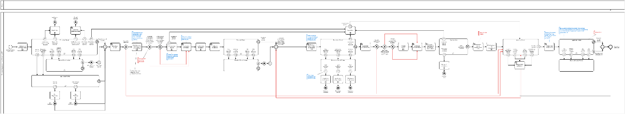

Figure 1. BPMN for the general process of a FA[5]

## Contracts based on a framework agreement

Figure 2 below shows the different processes for contracts based on framework agreements, using direct purchase, request for quotation and second stage competition which are detailed in the following sections.

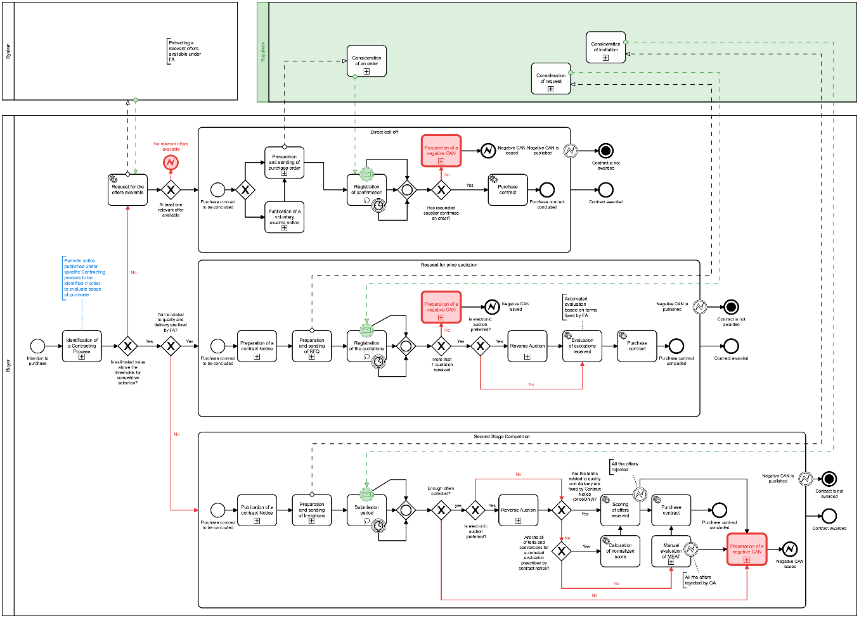

Figure 2. Framework Agreement Execution[6]

Direct purchase

The defined process for direct purchase is as follows:



Figure 3. Direct purchase under a framework agreement[7]

Direct purchase only applies to framework agreements that establish all the terms, otherwise a second-stage competition is necessary in order to precisely set the certain terms and conditions of the procurement that were not established in the framework agreement. Second stage competition aims to identify the supplier, out of participants of the framework agreement, with whom the public procurement contract shall be concluded. Publication of a PIN is not required by the EUPD.

**Framework agreements with a single supplier**

For framework agreements that are concluded with a single Economic Operator (a single selected supplier) Article 33.3 of the EUPD states that: “*Where a framework agreement is concluded with a single Economic Operator, contracts based on that agreement shall be awarded within the limits of the terms laid down in the framework agreement.*

*For the award of those contracts, Contracting Authorities may consult the Economic Operator party to the framework agreement in writing, requesting it to supplement its tender as necessary.*”

Therefore, for framework agreements in which all terms and conditions of the procurement are established when the framework agreement is concluded, additional information on the initial tender is not necessary. Therefore, purchase orders can be directly placed under the terms of the framework agreement to the single selected supplier.

**Framework agreements with multiple suppliers**

For framework agreements that establish all the terms and have a number of selected suppliers, Article 33.4 of the EUPD states that: “*Where a framework agreement is concluded with more than one Economic Operator, that framework agreement shall be performed in one of the following ways: (a) following the terms and conditions of the framework agreement, without reopening competition, where it sets out all the terms governing the provision of the works, services and supplies concerned and the objective conditions for determining which of the Economic Operators, party to the framework agreement, shall perform them; the latter conditions shall be indicated in the procurement documents for the framework agreement;(…)*”.

Therefore, the methodology for choosing between the selected suppliers of the framework agreement must be defined in the procurement documents of the framework agreement and the methodology must be objective, transparent and non-discriminatory. For example, it is possible to define a cascade method, where the buyer has to first contact the Economic Operator party to the framework agreement whose tender was considered best, and can only turn to the next best evaluated tenderer when the best selected supplier is not interested or cannot provide the goods, services or works required.

Second-stage competition

The defined process for second-stage competition is as follows:



Figure 4. Second-stage competition under a framework agreement[8]

Second-stage competition can be used in two cases:

* Framework agreements that establish all the terms, only when the possibility of reopening of competition has been set in the framework agreement, as stated in Article 33.4 of the EUPD: “*The choice of whether specific works, supplies or services shall be acquired following a reopening of competition or directly on the terms set out in the framework agreement shall be made pursuant to objective criteria, which shall be set out in the procurement documents for the framework agreement. These procurement documents shall also specify which terms may be subject to reopening of competition (…)*”;
* Framework agreements that do not establish all the terms, in any case.

In both cases, Article 33.2 must be taken into account: *“(…) Contracts based on a framework agreement may under no circumstances entail substantial modifications to the terms laid down in that framework agreement (…)*”.

**Framework agreements with a single supplier**

For framework agreements that are concluded with a single selected supplier, Article 33.3 of the EUPD states that: “*Where a framework agreement is concluded with a single Economic Operator, contracts based on that agreement shall be awarded within the limits of the terms laid down in the framework agreement.*

*For the award of those contracts, Contracting Authorities may consult the Economic Operator party to the framework agreement in writing, requesting it to supplement its tender as necessary.*”

It is therefore necessary for the buyer to require the single supplier of the framework agreement to provide further information in addition to its tender. If the single supplier provides a response, the purchase contract can be directly placed.

**Framework agreements with multiple suppliers**

Second-stage competition based on a framework agreement with multiples suppliers is regulated under Article 33.5 of the EUPD: “*The competitions (…) shall be based on the same terms as applied for the award of the framework agreement and, where necessary, more precisely formulated terms, and, where appropriate, other terms referred to in the procurement documents for the framework agreement, in accordance with the following procedure:*

*(a) for every contract to be awarded, Contracting Authorities shall consult in writing the Economic Operators capable of performing the contract;*

*(b) Contracting Authorities shall fix a time limit which is sufficiently long to allow tenders for each specific contract to be submitted, taking into account factors such as the complexity of the subject-matter of the contract and the time needed to send in tenders;*

*(c) tenders shall be submitted in writing, and their content shall not be opened until the stipulated time limit for reply has expired;*

*(d) Contracting Authorities shall award each contract to the tenderer that has submitted the best tender on the basis of the award criteria set out in the procurement documents for the framework agreement.*”

Although the award criteria for the awarding of specific contracts based on the framework agreement must be set in the procurement documents of the framework agreement, it is important to highlight that the award criteria do not have to be the same as those used for the conclusion of the framework agreement itself.

Article 35.2 allows the use of eAuction in second-stage competition: *“(…) an electronic auction may be held on the reopening of competition among the parties to a framework agreement (…)*”.

If electronic catalogues have been required within the framework agreement, Article 36.4 must also be taken into account: “*Where a framework agreement has been concluded with more than one Economic Operator following the submission of tenders in the form of electronic catalogues, Contracting Authorities may provide that the reopening of competition for specific contracts takes place on the basis of updated catalogues. In such a case, Contracting Authorities shall use one of the following methods:*

*(a) invite tenderers to resubmit their electronic catalogues, adapted to the requirements of the contract in question; or*

*(b) notify tenderers that they intend to collect from the electronic catalogues which have already been submitted the information needed to constitute tenders adapted to the requirements of the contract in question; provided that the use of that method has been announced in the procurement documents for the framework agreement.*”

Request for price quotation

The defined process for request for price quotation is as follows:



Figure 5. Request for price quotation under a framework agreement[9]

Request for price quotation is a specific case of second-stage competition, where the award of specific contracts is based solely on the lowest price. Therefore, all that has been detailed regarding second-stage competition also applies for this process.

# Framework agreement technical design

## Basic concept of a FA with the participation of a CPB

The diagram below shows a basic representation of the interaction between the main actors and data blocks involved in a FA:

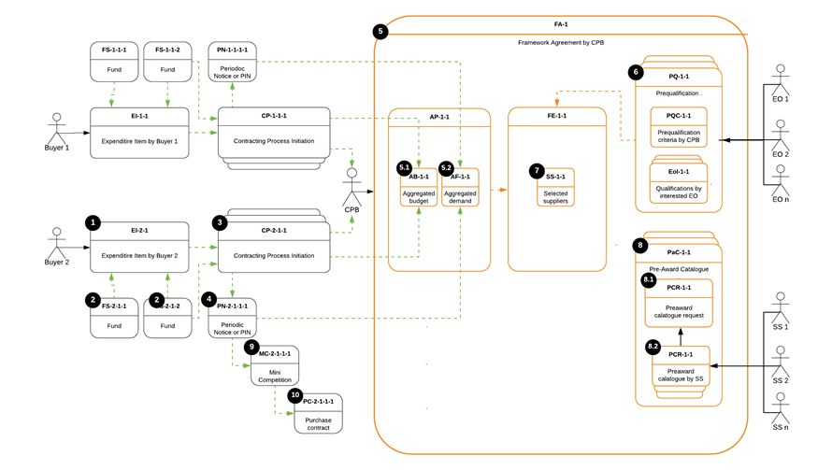

Figure 6 - Basic diagram of a FA with the participation of a CPB[10]

Main data blocks

|  |  |  |
| --- | --- | --- |
| **Data block** | **Acronym** | **Description** |
| Expenditure Item | EI | Describes a group of goods, services or works determined by specifying the parent CPV code that the CA intends to procure over a certain period, as well as the amount allocated by the CA to finance the purchases under this procurement procedure during the specified period. |
| Funding Source | FS | Describes a specific source of funds for the need from a primary EI. Contains information on both the amount and the organization that provides the funds, as well as on the parties involved in the disposal of these funds such as payer/donor. |
| Contracting Process | CP | Describes a process, so it does not match with an OCDS block. However, it is needed in the FA data model in order to store all the planning and tender information, and its relationship with other processes. |
| Periodic Notice | PN | Describes an announcement of the CA’s intention to conduct a procurement procedure (Aggregation demand notice). |
| Aggregated Plan | AP | Describes both aggregated demand and budget as per CPB analysis. |
| Framework Agreement | FA | Describes a specific instance of a FA initiated by a CPB. |
| Framework Establishment | FE | Describes the conclusion of a FA. |
| Aggregated Budget | AB | Describes the aggregated budget and its breakdown from all the CA, from which planned and requested demand is aggregated within this FA. |
| Aggregated Forecast | AF | Describes an aggregate forecast and its breakdown from all the CA, from which planned and requested demand is aggregated within this FA |
| Pre-qualification | PQ | Describes the pre-qualification phase(s) performed by the CPB for the conclusion of this FA. |
| Pre-qualification Criteria | PQC | Describes a set of exclusion and selection criteria, together with a scoring function (if applicable), as per CPBs' strategy. |
| Expression of Interest | EoI | Describes an interest expressed by an EO via submission of self-declaration to be qualified by the CPB. |
| Selected Suppliers | SS | Describes a list of EOs qualified by the CPB and included into this FA as parties. |
| Pre-award Catalogue Request | PCR | Describes a structured request for electronic catalogue with specific categories of goods or services for this FA provided by the CPB to the selected EOs. |
| Pre-award Catalogue | PAC | Describes a structured electronic catalogue with specific categories of goods or services for this FA and the relevant indicative prices received from selected EOs. |
| Mini-competition | MC | Describes a simplified competitive procurement process by the CA under a framework agreement. |
| Purchase Order | PO | Describes a structured request of a specific purchase by the CA sent to one or several EOs of this FA. |
| Purchase Contract | PC | Describes a contract concluded within this FA via one of the applicable methods allowed under the execution of a FA. |

Table 1 – Main data blocks involved in a FA

Main actors

|  |  |  |
| --- | --- | --- |
| **Actor** | **Acronym** | **Description** |
| Buyer | n/a | A CA, party of the FA, whose demand and budget are aggregated and included by a CPB into the FA. |
| Central Purchasing Body | CPB | CA providing centralised purchasing activities, responsible for the FA. |
| Economic Operator | EO | Any tenderer interested in participating in the FA. |
| Selected Supplier | SS | EO qualified by the CPB during the pre-qualification phase |

Table 2 – Main actors involved in a FA

Data flow

Taking as a reference the diagram with the basic representation of the interaction between the main actors and data blocks involved in a FA (figure 6), the table below shows the example of the use-case of Buyer 2:

|  |  |  |
| --- | --- | --- |
| **From** | **To** | **Description** |
| - | EI-2-1 | A specific need is identified (aggregated and weighted) and described by the CA (Buyer 2). |
| - | FS-2-1-n | Funds are identified and described. Linkages with target EI are established. |
| EI-2-1 | CP-2-1-1 | A procurement process for this EI (or a part of it) is initiated and specific Funding Sources (FS) enough to cover the assumed value of the contract are allocated from the FSs available for this parent EI. |
| CP-2-1-1 | PN-2-1-1-1 | The procurement process is initially planned: the forecast and assumed value are described, and a delivery deadline is indicated. |
| CP-2-1-1 | CPB | The CA provides all the information to the CPB, who will work with the aggregated demand and budget and will be responsible of the conclusion of the FA. |
| PN-2-1-1-1 | AF-1-1 | Procurement forecast described in the Periodic Notice (PN) is sent to be aggregated with the forecasts of other CAs by the CPB. |
| CP-2-1-1 | AB-1-1 | A budget breakdown described for this procurement process is sent to be aggregated with others by the CPB. |
| FA-1 | PQ-1-1 | A Pre-qualification round is initiated under this FA in order to select relevant (qualified) EOs to be invited to submit their offers (only in the case of a two-stage procedure such as restricted procedure). |
| PQ-1-1 | PQC-1-1 | A set of pre-qualification criteria is specified by the CPB in the CN under this pre-qualification round. |
| EO-n | EoI-1-n | Expressions of interest (EoI) are submitted by EOs within this pre-qualification round. |
| PQ-1-1 | SS-1-1 | The EOs to be invited to submit an offer are selected in this pre-qualification round (only in the case of a two-stage procedure such as restricted procedure). |
| FA-1 | PaC-1-1 | A Pre-Award Catalogue (PAC) with the specific services or goods to be purchased is issued by the CPB. |
| PaC-1-1 | PCR-1-1 | A Pre-award Catalogue Request (PCR) with the specific services or goods to be purchased is sent by the CPB to the selected EOs. |
| SS-n | PCR-1-n | A PAC response is received from EOs in response to the CPBs' PCR. |
| PaC-1-1 | MC-2-1-1-1 | A Mini-Competition (MC) procedure between those EOs that have been selected to be party of the FA is initiated by the CA (Buyer 2) under this FA in order to cover parent EI or a part of it. |
| MC-2-1-1-1 | PC-2-1-1-1 | A Purchase Contract (PC) is concluded between the CA (Buyer 2) and the EO winner of the MC. |

Table 3 – Main actors involved in a FA

## OCDS design

The diagram below shows the general data-set of a FA, which is a quite comprehensive and complex structure of the related transactional data which involves more than 10 parallel data-streams in its lifecycle:

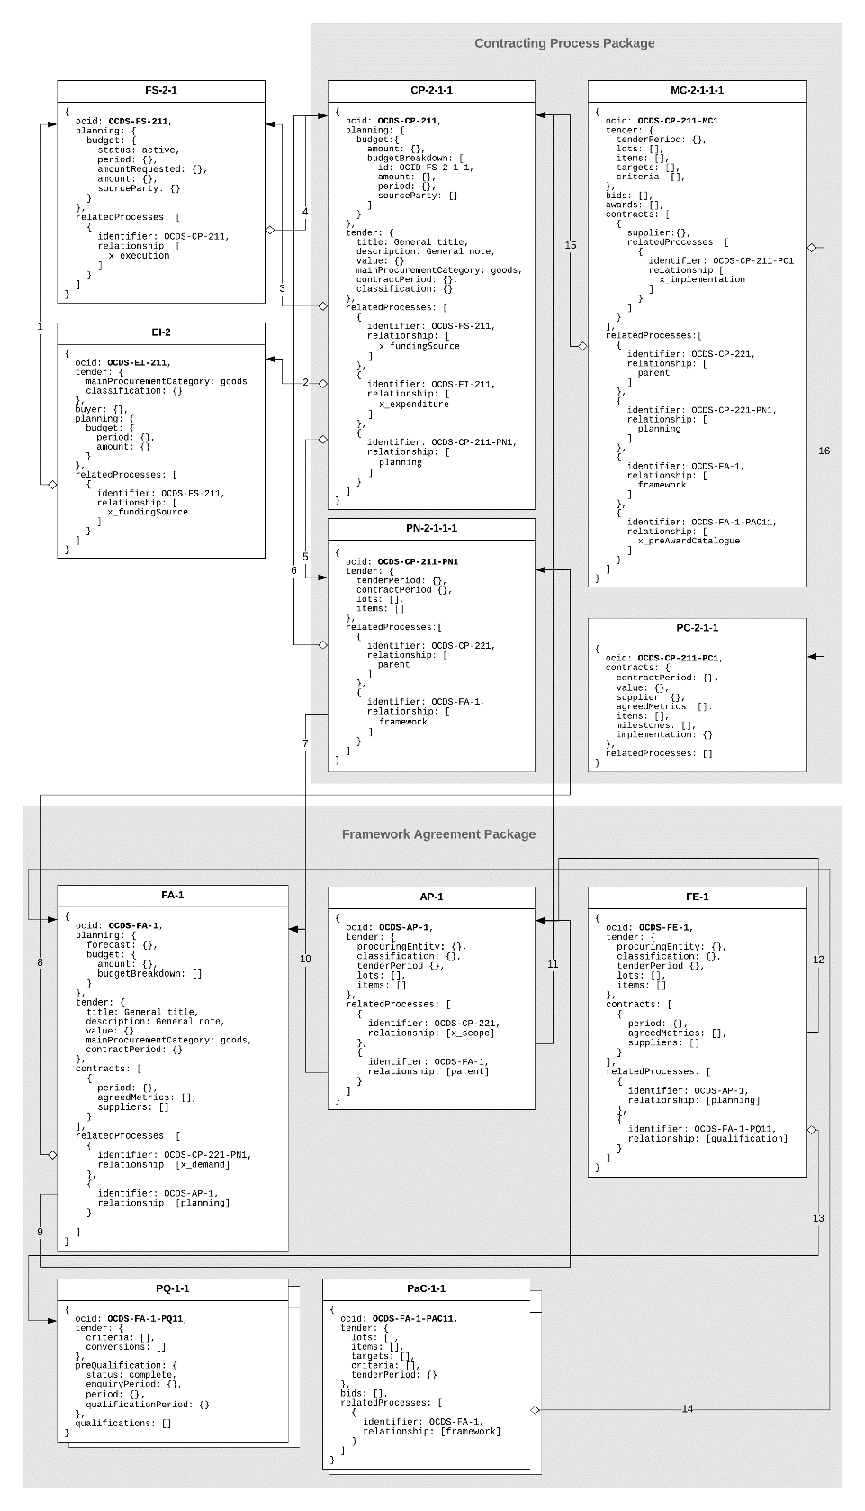

Figure 7 – OCDS design for a FA[11]

Map of relations

|  |  |  |  |
| --- | --- | --- | --- |
| **№** | **Description** | **Code** | **Precondition** |
| 1 | FS as a funds related source to EI | x_fundingSource | Funds associated by a CA with a specific need |
| 2 | EI as to related class of need to CP | x_expenditureItem | A procurement process is initiated by a CA based on a specific classified need |
| 3 | FS as allocated funds source to CP | x_fundingSource | Funds allocated by a CA to cover a future contract (or a part of it) |
| 4 | CP as a subsidized stream to FS | x_execution | Funds approved to cover a future contract (or a part of it) |
| 5 | PN as a planning phase to CP | planning | Procurement plan regarding a specific procurement process |
| 6 | CP as a parent to a PN | parent | Planning phase is started for this procurement process |
| 7 | FA as a related framework to PN | framework | FA indicated by a CA for further aggregation |
| 8 | PN as a demand requested to be included to FA | x_demand | Planned demand is requested by a CA to be included into the scope of a FA managed by a CPB |
| 9 | AP as a planning phase to FA | planning | Aggregated demand for a specific FA |
| 10 | FA as a parent to a AP | parent | Aggregated planning is started for this FA |
| 11 | PN as an aggregated scope to AP | x_scope | A request for participation is approved by the CPB, and therefore the CA's demand is aggregated to the FA |
| 12 | AP as an indicative forecast to FE | planning | FA is initiated by the CPB based on an aggregated plan for this FA |
| 13 | PQ as a pre-qualification phase to FE | qualification | Pre-qualification phase is started for this FA |
| 14 | FA as a managing framework to PaC | framework | PCR is issued by the CPB and sent to selected EOs |
| 15 | CP as a parent to MC | parent | FA execution is initiated under a specific procurement process aggregated by this FA |
| 16 | PC as implementation to MC | x_execution | Purchase contract is concluded under a FA with a specific procurement process |

Table 4 – Map of relations

OCDS parallel records used to reflect OCDS design for FAs

EI

|  |  |  |
| --- | --- | --- |
| **Attribute** | **Description** | **Covered by** |
| ocid | Global unique identifier for this EI | [OCDS 1.1](https://standard.open-contracting.org/latest/en/schema/identifiers/) |
| tender.mainProcurementCategory | Category of the subject of this EI | [OCDS 1.1](https://standard.open-contracting.org/latest/en/schema/codelists/#procurement-category) |
| tender.classification | CPV classification of the subject of this EI | Not covered |
| buyer | Organization in whose interests the need is declared | [OCDS 1.1.](https://standard.open-contracting.org/latest/en/schema/reference/#release) |
| planning.budget.period | The aggregated period of availability of funding sources under this EI | [core_extension](https://github.com/open-contracting-extensions/ocds_budget_breakdown_extension/blob/master/release-schema.json) |
| planning.budget.amount | The absolute total value of all the funding sources under this EI | [core_extension](https://github.com/open-contracting-extensions/ocds_budget_breakdown_extension/blob/master/release-schema.json) |
| relatedProcesses | The link to the funding sources allocated for this EI | [OCDS 1.1](https://standard.open-contracting.org/latest/en/schema/reference/?highlight=relatedProcess#relatedprocess) |

Table 5 – Attributes of EI

FS

|  |  |  |
| --- | --- | --- |
| **Attribute** | **Description** | **Covered by** |
| ocid | Global unique identifier for this FS | [OCDS 1.1](https://standard.open-contracting.org/latest/en/schema/identifiers/) |
| planning.budget.period | The period of availability of this FS | [core_extension](https://github.com/open-contracting-extensions/ocds_budget_breakdown_extension/blob/master/release-schema.json) |
| planning.budget.amount | The absolute value of this FS | [core_extension](https://github.com/open-contracting-extensions/ocds_budget_breakdown_extension/blob/master/release-schema.json) |
| planning.budget.amountRequested | Future steps of representing the workflow of budget approvals | [Issue #616](https://github.com/open-contracting/standard/issues/616) |
| planning.budget.status | Future steps of representing the workflow of budget approvals | [Issue #616](https://github.com/open-contracting/standard/issues/616) |
| planning.budget.sourceParty | The organization related to this FS | [core_extension](https://github.com/open-contracting-extensions/ocds_budget_breakdown_extension/blob/master/release-schema.json) |
| relatedProcesses | The link to an EI this FS is related to | [OCDS 1.1](https://standard.open-contracting.org/latest/en/schema/reference/?highlight=relatedProcess#relatedprocess) |

Table 6 – Attributes of FS

CP

|  |  |  |
| --- | --- | --- |
| **Attribute** | **Description** | **Covered by** |
| ocid | Global unique identifier for this procurement process | [OCDS 1.1](https://standard.open-contracting.org/latest/en/schema/identifiers/) |
| planning.budget.amount | The overall value of the funds allocated for this procurement process | [core_extension](https://github.com/open-contracting-extensions/ocds_budget_breakdown_extension/blob/master/release-schema.json) |
| planning.budget.budgetBreakdown | Detailed budget breakdown under this procurement process, covering multiple budget funding and multiple periods | [core_extension](https://github.com/open-contracting-extensions/ocds_budget_breakdown_extension/blob/master/release-schema.json) |
| tender.title | An overall title for this procurement process | [OCDS 1.1.](https://standard.open-contracting.org/latest/en/schema/reference/#release) |
| tender.description | An overall description for this procurement process | [OCDS 1.1.](https://standard.open-contracting.org/latest/en/schema/reference/#release) |
| tender.value | The total upper estimated value of the procurement process | [OCDS 1.1.](https://standard.open-contracting.org/latest/en/schema/reference/#release) |
| tender.mainProcurementCategory | Category of the subject of this procurement process | [OCDS 1.1](https://standard.open-contracting.org/latest/en/schema/codelists/#procurement-category) |
| tender.classification | CPV classification of the subject of this procurement process | Not covered |
| buyer | Organization in whose interests the need is declared | [OCDS 1.1.](https://standard.open-contracting.org/latest/en/schema/reference/#release) |
| tender.contractPeriod | The period over which the contract is estimated or required to be active | [OCDS 1.1](https://standard.open-contracting.org/latest/en/schema/reference/#tender) |
| relatedProcesses | Parallel processes related to a current one | [OCDS 1.1](https://standard.open-contracting.org/latest/en/schema/reference/#tender) |
| *.relationship: x_fundingSource | Link to related FS(s) | [OCDS 1.1](https://standard.open-contracting.org/latest/en/schema/reference/?highlight=relatedProcess#relatedprocess) |
| *.relationship: x_expenditure | Link to related EI(s) | [OCDS 1.1](https://standard.open-contracting.org/latest/en/schema/reference/?highlight=relatedProcess#relatedprocess) |
| *.relationship: planning | Link to related PN | [OCDS 1.1](https://standard.open-contracting.org/latest/en/schema/reference/?highlight=relatedProcess#relatedprocess) |
| *.relationship: x_framework | Link to related FA (when subject is included in a FA) | [OCDS 1.1](https://standard.open-contracting.org/latest/en/schema/reference/?highlight=relatedProcess#relatedprocess) |

Table 7 – Attributes of CP

PN

|  |  |  |
| --- | --- | --- |
| **Attribute** | **Description** | **Covered by** |
| ocid | Global unique identifier for the PN under this procurement process | [OCDS 1.1](https://standard.open-contracting.org/latest/en/schema/reference/#release) |
| tender.tenderPeriod | Indicative date (month or quarter) of call for proposals under this procurement process | [OCDS 1.1](https://standard.open-contracting.org/latest/en/schema/reference/#tender) |
| tender.contractPeriod | Expected contract period for a contract concluded under this procurement process | [OCDS 1.1](https://standard.open-contracting.org/latest/en/schema/reference/#tender) |
| tender.lots | Provisional division into lots | [core_extension](https://github.com/open-contracting-extensions/ocds_lots_extension) |
| tender.items | Provisional nomenclature of a subject of procurement | [OCDS 1.1](https://standard.open-contracting.org/latest/en/schema/reference/#tender) |
| relatedProcesses | Link to the parent procurement process | [OCDS 1.1](https://standard.open-contracting.org/latest/en/schema/reference/?highlight=relatedProcess#relatedprocess) |

Table 8 – Attributes of PN

MC

|  |  |  |
| --- | --- | --- |
| **Attribute** | **Description** | **Covered by** |
| ocid | Global unique identifier for the MC under this procurement process | [OCDS 1.1](https://standard.open-contracting.org/latest/en/schema/reference/#release) |
| tender.tenderPeriod | Period for submitting a bids in this MC | [OCDS 1.1](https://standard.open-contracting.org/latest/en/schema/reference/#tender) |
| tender.lots | Lots of this MC | [core_extension](https://github.com/open-contracting-extensions/ocds_lots_extension) |
| tender.items | Nomenclature of this MC | [OCDS 1.1](https://standard.open-contracting.org/latest/en/schema/reference/#tender) |
| tender.criteria | Any evaluation criteria applied for this MC | [core_extension](https://github.com/open-contracting-extensions/ocds_requirements_extension) |
| tender.targets | Any indicative metrics criteria applied for this MC | [core_extension](https://github.com/open-contracting-extensions/ocds_metrics_extension) |
| bids | List of tenders collected under this MC | [core_extension](https://github.com/open-contracting-extensions/ocds_bid_extension) |
| awards | Award-decision taken under this MC | [OCDS 1.1](https://standard.open-contracting.org/latest/en/schema/reference/#tender) |
| contracts[*].supplier | List of suppliers awarded under this MC | [OCDS 1.1](https://standard.open-contracting.org/latest/en/schema/reference/#tender) |
| contract[*].AwardID | Reference on award for purchase contract concluded under this MC | [OCDS 1.1](https://standard.open-contracting.org/latest/en/schema/reference/#tender) |
| relatedProcesses | Parallel processes related to a current one | [OCDS 1.1](https://standard.open-contracting.org/latest/en/schema/reference/?highlight=relatedProcess#relatedprocess) |
| *.relationship: parent | Link to a procurement process | [OCDS 1.1](https://standard.open-contracting.org/latest/en/schema/reference/?highlight=relatedProcess#relatedprocess) |
| *.relationship: planning | Link to PN | [OCDS 1.1](https://standard.open-contracting.org/latest/en/schema/reference/?highlight=relatedProcess#relatedprocess) |
| *.relationship: framework | Link to FA | [OCDS 1.1](https://standard.open-contracting.org/latest/en/schema/reference/?highlight=relatedProcess#relatedprocess) |
| *.relationship: x_preAwardCatalogue | Link to PCR | [OCDS 1.1](https://standard.open-contracting.org/latest/en/schema/reference/?highlight=relatedProcess#relatedprocess) |

Table 9 – Attributes of MC

PC

|  |  |  |
| --- | --- | --- |
| **Attribute** | **Description** | **Covered by** |
| ocid | Global unique identifier for the PC under this procurement process | [OCDS 1.1](https://standard.open-contracting.org/latest/en/schema/reference/#release) |
| contracts[*].contractPeriod | A period for this PC | [OCDS.1.1](https://standard.open-contracting.org/latest/en/schema/reference/#contract) |
| contracts[*].supplier | The EO winner of this PC | [OCDS.1.1](https://standard.open-contracting.org/latest/en/schema/reference/#contract) |
| contracts[*].value | The value of this PC | [OCDS.1.1](https://standard.open-contracting.org/latest/en/schema/reference/#contract) |
| contracts[*].agreedMetrics | The metrics agreed under this PC | [core_extension](https://github.com/open-contracting-extensions/ocds_metrics_extension) |
| contracts[*].items | A scope of performance under this PC | [OCDS.1.1](https://standard.open-contracting.org/latest/en/schema/reference/#contract) |
| contracts[*].milestones | The milestones of this PC | [OCDS.1.1](https://standard.open-contracting.org/latest/en/schema/reference/#contract) |
| contracts[*].implementation | An implementation record under this PC | [OCDS.1.1](https://standard.open-contracting.org/latest/en/schema/reference/#contract) |

Table 10 – Attributes of PC

FA

|  |  |  |
| --- | --- | --- |
| **Attribute** | **Description** | **Covered by** |
| ocid | Global unique identifier for this FA | [OCDS 1.1](https://standard.open-contracting.org/latest/en/schema/reference/?highlight=relatedProcess#relatedprocess) |
| planning.forecast | The indicative scope of this FA | [core_extension](https://github.com/open-contracting-extensions/ocds_metrics_extension) |
| tender.title | Title for the FA | [OCDS 1.1](https://standard.open-contracting.org/latest/en/schema/reference/?highlight=relatedProcess#relatedprocess) |
| tender.description | Description for the FA | [OCDS 1.1](https://standard.open-contracting.org/latest/en/schema/reference/?highlight=relatedProcess#relatedprocess) |
| tender.value | Indicative value of this FA | [OCDS 1.1](https://standard.open-contracting.org/latest/en/schema/reference/?highlight=relatedProcess#relatedprocess) |
| tender.mainProcurementCategory | Main procurement category of this FA | [OCDS 1.1](https://standard.open-contracting.org/latest/en/schema/reference/?highlight=relatedProcess#relatedprocess) |
| tender.contractPeriod | Indicative duration of this FA | [OCDS 1.1](https://standard.open-contracting.org/latest/en/schema/reference/?highlight=relatedProcess#relatedprocess) |
| contracts | List of PCs concluded under this FA | [OCDS 1.1](https://standard.open-contracting.org/latest/en/schema/reference/?highlight=relatedProcess#relatedprocess) |
| relatedProcesses | List of parallel processes related to this FA | [OCDS 1.1](https://standard.open-contracting.org/latest/en/schema/reference/?highlight=relatedProcess#relatedprocess) |
| *.relationship: x_demand | Link to PNs | [OCDS 1.1](https://standard.open-contracting.org/latest/en/schema/reference/?highlight=relatedProcess#relatedprocess) |
| *.relationship: planning | Link to AP | [OCDS 1.1](https://standard.open-contracting.org/latest/en/schema/reference/?highlight=relatedProcess#relatedprocess) |

Table 11 – Attributes of FA

AP

|  |  |  |
| --- | --- | --- |
| **Attribute** | **Description** | **Covered by** |
| ocid | Global unique identifier for the AP under this FA | [OCDS 1.1](https://standard.open-contracting.org/latest/en/schema/reference/?highlight=relatedProcess#relatedprocess) |
| tender.classification | Classification of this AP according to CPV | [OCDS 1.1](https://standard.open-contracting.org/latest/en/schema/reference/?highlight=relatedProcess#relatedprocess) |
| tender.tenderPeriod | Indicative start date for the conclusion of the FA | [OCDS 1.1](https://standard.open-contracting.org/latest/en/schema/reference/?highlight=relatedProcess#relatedprocess) |
| tender.items | Nomenclature of this AP | [OCDS 1.1](https://standard.open-contracting.org/latest/en/schema/reference/?highlight=relatedProcess#relatedprocess) |
| tender.lots | Lots this AP is divided into | [core_extension](https://github.com/open-contracting-extensions/ocds_lots_extension) |
| relatedProcesses | Parallel processes related to this AP | [OCDS 1.1](https://standard.open-contracting.org/latest/en/schema/reference/?highlight=relatedProcess#relatedprocess) |
| *.relationship: x_scope | Link to PNs | [OCDS 1.1](https://standard.open-contracting.org/latest/en/schema/reference/?highlight=relatedProcess#relatedprocess) |
| *.relationship: parent | Link to FA | [OCDS 1.1](https://standard.open-contracting.org/latest/en/schema/reference/?highlight=relatedProcess#relatedprocess) |

Table 12 – Attributes of AP

FE

|  |  |  |
| --- | --- | --- |
| **Attribute** | **Description** | **Covered by** |
| ocid | Global unique identifier for the FE under this FA | [OCDS 1.1](https://standard.open-contracting.org/latest/en/schema/reference/?highlight=relatedProcess#relatedprocess) |
| tender.procuringEntity | CA in this FA | [OCDS 1.1](https://standard.open-contracting.org/latest/en/schema/reference/?highlight=relatedProcess#relatedprocess) |
| tender.classification | Classification of this FA according to CPV | [OCDS 1.1](https://standard.open-contracting.org/latest/en/schema/reference/?highlight=relatedProcess#relatedprocess) |
| relatedProcesses | Parallel processes related to this FE | [OCDS 1.1](https://standard.open-contracting.org/latest/en/schema/reference/?highlight=relatedProcess#relatedprocess) |
| *.relationship: planning | Link to AP | [OCDS 1.1](https://standard.open-contracting.org/latest/en/schema/reference/?highlight=relatedProcess#relatedprocess) |
| *.relationship: qualification | Link to PQ | [OCDS 1.1](https://standard.open-contracting.org/latest/en/schema/reference/?highlight=relatedProcess#relatedprocess) |

Table 13 – Attributes of FE

PQ

|  |  |  |
| --- | --- | --- |
| **Attribute** | **Description** | **Covered by** |
| ocid | Global unique identifier for the PQ under this FA | [OCDS 1.1](https://standard.open-contracting.org/latest/en/schema/reference/?highlight=relatedProcess#relatedprocess) |
| preQualification.enquiryPeriod | Enquiry period allocated under this PQ | [core_extension](https://github.com/open-contracting-extensions/ocds_qualification_extension) |
| preQualification.period | Period for submission of EoIs | [core_extension](https://github.com/open-contracting-extensions/ocds_qualification_extension) |
| preQualification.qualificationPeriod | Period for consideration of EoIs collected by the CA | [core_extension](https://github.com/open-contracting-extensions/ocds_qualification_extension) |
| submissions | EoIs by interested EOs | Not covered |
| qualifications | Qualification decisions by the CA against received EoI | Not covered |

Table 14 – Attributes of PQ

PQC

|  |  |  |
| --- | --- | --- |
| **Attribute** | **Description** | **Covered by** |
| tender.criteria | Any qualification and/or evaluation criteria applied by the CA | [core_extension](https://github.com/open-contracting-extensions/ocds_requirements_extension) |
| tender.conversions | Any weighting related to applied criteria | Not covered |
| tender.otherCriteria | Detailed information about any other requirements or techniques used by the CA | [core_extension](https://github.com/open-contracting-extensions/ocds_otherRequirements_extension) |

Table 15 – Attributes of PQC

PAC

|  |  |  |
| --- | --- | --- |
| **Attribute** | **Description** | **Covered by** |
| ocid | Global unique identifier for the PAC under this FA | [OCDS 1.1](https://standard.open-contracting.org/latest/en/schema/reference/?highlight=relatedProcess#relatedprocess) |
| tender.items | Nomenclature requested by the CA within PCR | [OCDS 1.1](https://standard.open-contracting.org/latest/en/schema/reference/?highlight=relatedProcess#relatedprocess) |
| tender.targets | Any targets indicated by the CA within PCR | [core_extension](https://github.com/open-contracting-extensions/ocds_metrics_extension) |
| tender.criteria | Evaluation criteria related to a nomenclature requested by this PCR | [core_extension](https://github.com/open-contracting-extensions/ocds_requirements_extension) |
| tender.tenderPeriod | Period for submission of PACs by invited EOs | [OCDS 1.1](https://standard.open-contracting.org/latest/en/schema/reference/?highlight=relatedProcess#relatedprocess) |
| bids | PACs submitted by invited EOs | [core_extension](https://github.com/open-contracting-extensions/ocds_bid_extension) |
| relatedProcesses | Parallel processes related to this PAC | [OCDS 1.1](https://standard.open-contracting.org/latest/en/schema/reference/?highlight=relatedProcess#relatedprocess) |
| *.relationship: framework | Link to FA | [OCDS 1.1](https://standard.open-contracting.org/latest/en/schema/reference/?highlight=relatedProcess#relatedprocess) |

Table 16 – Attributes of PAC

## Conclusion of a FA

All the aforementioned blocks are involved in the entire FA lifecycle (conclusion of the FA and execution of the FA). However, regarding the conclusion of a FA, only the following are necessary:

|  |  |
| --- | --- |
| **Block** | **Description** |
| FA | Describes a specific instance of a FA initiated by a CPB. |
| AP | Describes aggregate demand as per CPB analysis. |
| FE | Describes the conclusion of the FA. |
| PAC | Describes a structured electronic catalogue with specific categories of goods or services for a FA, as well as the relevant indicative prices received from selected EOs (in the case of request of electronic catalogues to the selected EOs) |

Table 17 - OCDS blocks involved in the conclusion of a FA

Regarding building components, only the following are relevant for the conclusion of a FA:

* Initiation of a FA: Offline process conducted by the CPB. It is based on the analysis of CAs’ demands described through the lists of EIs as a part of their budgeting process. Having all the needs described by the CAs that want to be party of the FA, the CPB can determine the global needs and specificities of the FA (overall value, geographical distribution, timings, etc.). The main goal of this stage is to decide on the procurement strategy for the conclusion of the FA and inform the CAs;
* Aggregated planning: It contains information about multiple individual procurement plans. Through the aggregation of demand, CPBs are able to significantly diminish costs and get better value for money through economies of scale, although procurement techniques that involve aggregation, such as FA, usually take longer to award than non-aggregated procurement processes;
* Design of a FA: Based on the procurement strategy adopted by the CPB, the relevant aspects regarding the conclusion and execution of the FA are defined in order to initiate the FA process;
* Conclusion of a FA: FAs are frequently set by CPBs, which can either act on their own behalf or on behalf of a number of CAs. The successful tenderers are usually selected using open or restricted procedures (although negotiated procedures can also be used when the appropriate conditions are met). The FA determines the method in which specific contracts based on the FA will be awarded to selected EOs, as well as the terms applying to that awards for a certain period of time;
* Pre-award catalogue request: The PAC provides a list and high-level information and requirements on the goods or services included within the FA, in order for the EOs to be able to decide whether they have the capacity and are interested or not in being party of the FA. A PAC request does not contain any vendor-specific data.

Initiation of a FA

The diagram below shows the processes for the initiation of a FA:

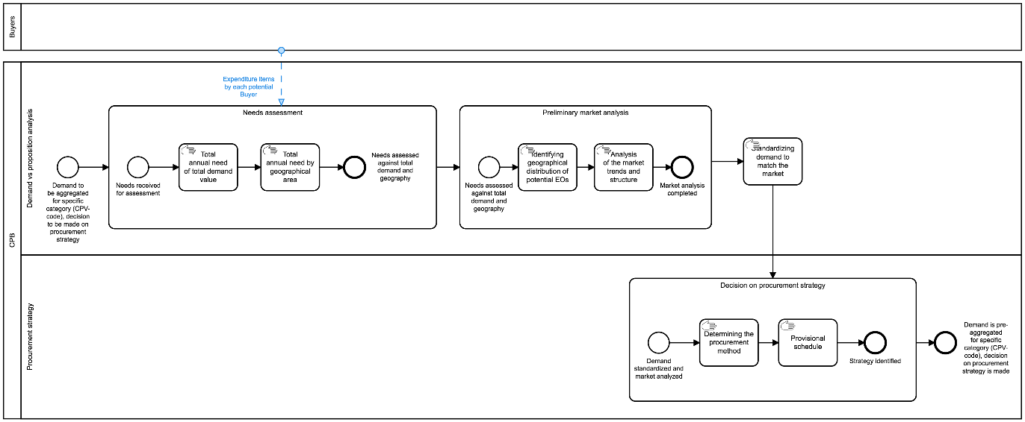

Figure 8 - BPMN for initiation of a FA[12]

All actions regarding aggregation of demand and budget are described in the following section.

Aggregated planning

BPMN

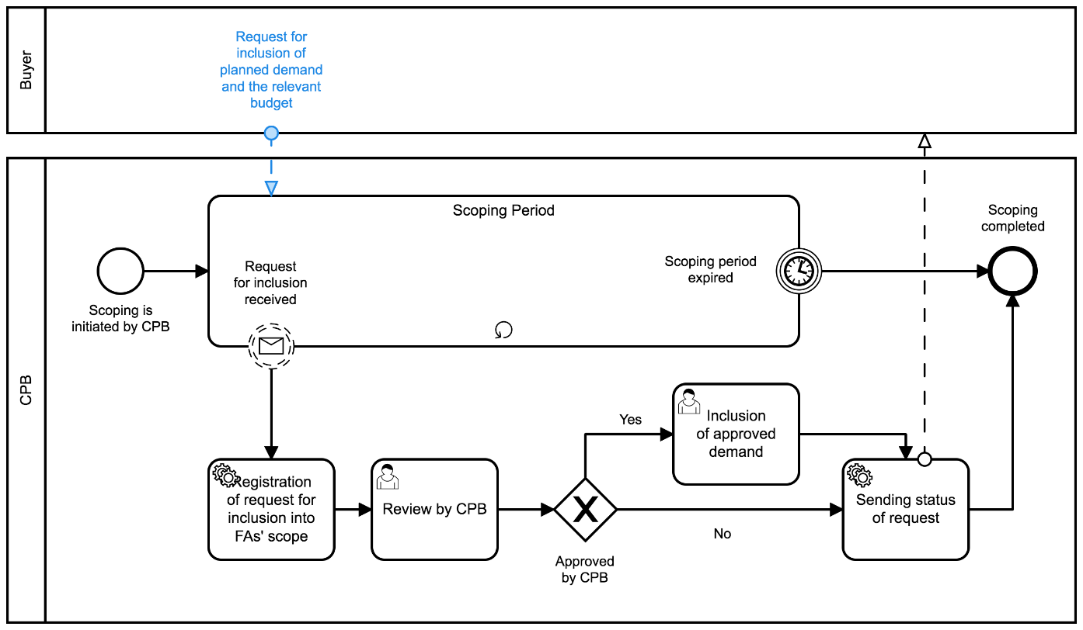

Figure 9 - BPMN for aggregated planning[13]

Component diagram

On a data level, aggregation means setting up a relationship between different data-sets and inheritance of specific data in order to reflect aggregation and its scope. The logic illustrated in the following component diagram consists of a sequence of relations of sets based on the business process performed:

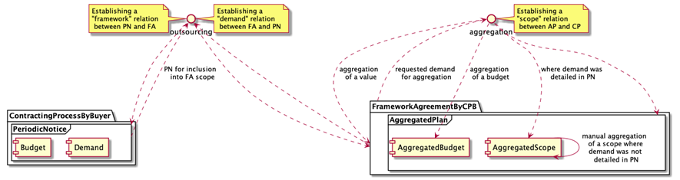

Figure 10 – Component diagram for aggregated planning

According to the business process above, once a CA becomes aware of the intention of a CPB to conduct a FA for a specific category of goods or services, the CA can request the CPB the inclusion of the CA’s demand and related budget into the scope of the FA. In order to do so, the CA needs to describe the demand against previously declared annual needs (EI classified with a certain CPV code) and publication of a relevant PN (the aggregation demand notice) describing the provisional schedule, budget allocated, etc. Once these data is provided by the CA, a relation between the PN and the FA can be established. Such a relation serves as a data-hook of inclusion requests recorded.

On the CPB side, each request for inclusion from a CA has to be reviewed by the CPB, who will decide on whether this request is a subject of this FA from different perspectives (classification, geography, volume, etc.). If it is compliant and the CPB decides to include this demand into the scope of the future FA, such demand is aggregated through establishing a relation between the PN and the aggregated plan.

The CPB proceeds in the same way with all the requests collected during a certain period of time and, having the final aggregated scope, the CPB can complete the scoping period and start designing the FA and preparing the pre-qualification phase.

Design of a FA

Determining categories and products

FAs are usually used for repeating needs and enable CAs to manage procurement when they cannot objectively foresee the exact type and/or amount of supplies, services and works for the duration of a given period.

During the design of the FA, the categories and products that will be purchased under this FA must be defined, as well as the possibility of substitution and to what extent. However, when certain terms and conditions of the procurement cannot be established with sufficient precision in the conclusion of the FA, the CA will be able to establish or refine them through MC processes under the FA.

Technically, determining product categories is the determination of a relevant list of items with aggregated classification according to CPV and decomposed place of performance (delivery).

Find below the simplest case, when the only category of goods scoped for relatively same (or even same) geography:

|  |
| --- |
| {  "tender": {  "items": [  {  "id": "001",  "description": "Notebooks",  "quantity": 200,  "classification": {  "schema": "CPV",  "id": "30213100-6",  "description": "Portable computers"  }  },  "deliveryAddress": {  "region": "Florida"  }  ]  }  } |

Figure 11 – Simplest case

Find below a more complex case when a common volume in a category of goods is divided through geography:

|  |
| --- |
| {  "tender": {  "items": [  {  "id": "001",  "description": "Notebooks",  "quantity": 150,  "classification": {  "schema": "CPV",  "id": "30213100-6",  "description": "Portable computers"  }  },  "deliveryAddress": {  "region": "Florida"  },  {  "id": "002",  "description": "Notebooks",  "quantity": 50,  "classification": {  "schema": "CPV",  "id": "30213100-6",  "description": "Portable computers"  }  },  "deliveryAddress": {  "region": "California"  }  ]  } |

Figure 12 – Complex case

Decision on minimum technical specifications

FAs are not a specific procurement procedure or a type of procurement, but a technique for aggregated procurement used for established and repetitive needs when the CA does not know in advance either the exact contract amount and/or exactly when the need will occur. Therefore, FAs allow CAs to set the parameters for purchases without having to define the precise amounts or the full specifications, providing streamlined processes for standardized purchases. Subsequently, contracts based on a FA will be conducted only with the EOs that are party to this FA.

Therefore, two different stages must be considered regarding FAs:

1. Conclusion on the FA: In order to conclude a FA, CAs can use any of the usual procedures, and open and restricted procedures are usually applied. Consequently, the normal processes and normal rules apply, in particular those concerning publicity, time limits, criteria for exclusion, selection and award. The conclusion of the FA ends with the selection of the EOs that will be party of the FA.
2. Contracts under the FA: Different processes can be conducted for contracts based on FAs, such as direct purchase, request for quotation and second stage competition. Only those EOs party of the FA, that is, that were selected during the conclusion of the FA, can be awarded contracts under this FA.

When a CA deals with a large portfolio of products (for example 10,000 types of office supplies) the question arises, whether all these products must be identified and considered at the award stage in the FA, and to what extent they need to be described. It seems to be reasonable to describe the subject matter in a broad manner since such an approach gives the flexibility needed both when concluding a framework agreement and when using it.

On the other hand, a sort of balance in clarity for both CA and EOs can be achieved by including a clear, precise and unequivocal review clause in the framework agreement, in which it is predicted that a substitution of products is allowed. Such review clauses shall state the scope and nature of possible modifications or options, as well as the conditions under which they may be used. They shall not provide for modifications or options that would alter the overall nature of the framework agreement. What needs to be considered in drafting the review clauses is, whether the allowed substitution regards a change of a product for a new one, but with the terms of keeping the agreed price, or whether the substitution will allow an upgrade of a product connected with a price increase.

Technically, decisions on minimum technical specification and introduction of relevant review clauses are the determination of a list of targets and criteria for each bunch of such technical specifications expressed with a review clause. targets describe a list of minimum, maximum and expected allowed values or its ranges for the certain attributes of a particular category (item), and criteria is a way on how to requisite EOs’ offers against prescribed targets:

|  |
| --- |
| {  "tender": {  "items": [  {  "id": "001",  "description": "Simple notebooks",  "quantity": 100,  "classification": {  "schema": "CPV",  "id": "30213100-6",  "description": "Portable computers"  },  "deliveryAddress": {  "region": "Florida"  }  }  ],  "targets": [  {  "id": "001",  "title": "Product metrics",  "description": "Minimum technical requirements",  "relatesTo": "item",  "relatedItem": "001",  "observations": [  {  "id": "001-1",  "note": "Diagonal",  "measure": 15,  "unit": {  "id": "",  "name": "inches"  },  "relatedRequirementID": "001-1-2"  },  {  "id": "001-2",  "note": "HDD Volume",  "measure": 102400,  "unit": {  "id": "",  "name": "Mbyte"  },  "relatedRequirementID": "001-1-4"  }  ]  },  {  "id": "002",  "title": "Estimated maximum budget",  "description": "Exepected maximum unit price",  "relatesTo": "item",  "relatedItem": "001",  "observations": [  {  "id": "002-1",  "note": "Unit price in UAH",  "value": {  "amount": 25000,  "currency": "UAH",  "valueAddedTaxIncluded": true  }  }  ]  }  ],  "criteria": [  {  "id": "007",  "title": "Characteristics",  "relatesTo": "item",  "relatedItem": "001",  "requirementGroups": [  {  "id": "001-1",  "requirements": [  {  "id": "001-1-1",  "title": "Processor family",  "dataType": "string"  },  {  "id": "001-1-2",  "title": "Diagonal",  "dataType": "number",  "minValue": 15  },  {  "id": "001-1-3",  "title": "RAM Volume",  "dataType": "integer"  },  {  "id": "001-1-4",  "title": "HDD Volume",  "dataType": "integer",  "minValue": 102400  }  ]  }  ]  }  ]  }  } |

Figure 13 – Simplest case

As shown in the example above, criteria in this context can be used not only against metrics prescribed but also in order to describe any other information not covered by any observation, but needed from a requisition perspective.

Decision on lots

FAs can be divided into lots. Technically, the decision on lots is a determination of a relevant list of lots with aggregated classification according to CPV.

|  |
| --- |
| {  "tender": {  "lots": [  {  "id": "001",  "status": "active",  "title": "Simple notebooks",  "classification": {  "scheme": "CPV",  "id": "30213100-6",  "description": "Portable computers"  }  },  {  "id": "002",  "status": "active",  "title": "Advanced notebooks",  "classification": {  "scheme": "CPV",  "id": "30213100-6",  "description": "Portable computers"  }  }  ]  }  } |

Figure 14 – Division into lots

Determining the characteristics of the FA

**Fixed and non-fixed terms**

When it comes to FAs that do not include all terms and conditions, it will be necessary to establish or refine all non-fixed terms through MCs conducted under this FA:

* Information about options regarding additional purchases: A CA may have the right (but not the obligation) to additional purchases from an EO while the contract is valid. For example, a contract may concern a thousand uniforms, and the CA may have the option to request an additional hundred uniforms. This may be useful when, with the conclusion of the FA, the CA doesn't yet know whether a planned increase in staff will take place.

The options.hasOptions field can be set to true, and the options.description field can describe the options for additional purchases. hasOptions and options.description can also be set on Lot objects in the tender.lots array:

|  |
| --- |
| {  "tender": {  "lots": [  {  "id": "001",  "options": {  "hasOptions": true,  "description": "The buyer has the option to buy an additional hundred uniforms."  }  }  ]  }  } |

Figure 15 – Options for additional purchases

* Information on the recurrence of the procurement process. It indicates that the contract is likely to be re-launched or re-established in the foreseeable future. Note that this does not mean awarding multiple contracts within a single FA; in these cases, these fields should not be used. This information can be useful, for example, to EOs deciding whether to invest or not into machinery necessary for a particular contract since, with this information, they know that there will likely be an opportunity to win similar contracts in future years, which may make the investment more worthwhile.

|  |
| --- |
| {  "tender": {  "lots": [  {  "id": "001",  "renewals": {  "hasRenewals": true,  "variantsDetails": "Contracts are due to be renewed one time at the end of the initial term"  }  }  ]  }  } |

Figure 16 – Renewals

* Information about variants

|  |
| --- |
| {  "tender": {  "lots": [  {  "id": "001",  "variants": {  "hasVariants": true,  "variantsDetails": "Any relevant items are permitted"  }  }  ]  }  } |

Figure 17 – Variants

**Duration**

The duration of a FA shall not exceed four years, save in exceptional cases duly justified, in particular by the subject of the FA.

|  |
| --- |
| {  "tender": {  "lots": [  {  "id": "001",  "contractPeriod": {  "durationInMonth": 36,  "startDate": "",  "endDate": ""  }  }  ]  }  } |

Figure 18 – Duration of the FA

**Limitations on the number of selected EOs**

There is no limitation on the maximum number of EOs that can be party of a multi-supplier FA, but if the CA wants to establish a maximum, it must be indicated in the Contract Notice. When this is a case, pre-selection instead of pre-qualification will be conducted in order to score all the candidates.

To limit the number of selected EOs, secondStage building block shall be within inside the tender (or even for a given specific lot)as shown below:

* For tender:

|  |
| --- |
| {  "tender": {  "secondStage": {  "minimumCandidates": 2,  "maximumCandidates": 5  }  }  } |

Figure 19 – Limitation on the number of candidates at tender level

* For a specific lot:

|  |
| --- |
| {  "tender": {  "lots": [  {  "secondStage": {  "minimumCandidates": 2,  "maximumCandidates": 5  }  }  ]  }  } |

Figure 20 – Limitation on the number of candidates at lot level

Other criteria

Other requirements for participation and terms governing the limitation of the number of candidates to be invited to submit a bid, can be defined using secondStage.

Technically, the definition of other requirements is an indication of a code of a core criterion to be applied for a future limitation of the number of candidates to be invited to submit a bid, as reductionCriteria and the specification of a way of how this criterion can be applied with qualificationSystemMethods:

* reductionCriteria
  + When reductionCriteria: scoring, there is a limitation of the number of candidates to be invited. The values for further qualification for reduction will be scored either automatically or manually (depending on the qualificationSystemMethods), based on the set of relevant requirementResponses received from EOs in response to the requirements indicated by the CA;
  + when reductionCriteria: none, there is no limit for the number of candidates to be invited to submit a bid.
* qualificationSystemMethods
  + When qualificationSystemMethods: automated, the selection of EOs will be approached automatically.
  + where qualificationSystemMethods: manual - the selection of EOs will be approached manually by the CA;

The otherCriteria block is expressed as a separate building block in accordance with: <https://github.com/open-contracting-extensions/ocds_otherRequirements_extension>

|  |
| --- |
| {  "tender": {  "otherCriteria": {  "qualificationSystemMethods": [  "automated"  ],  "reductionCriteria": "scoring"  }  }  } |

Figure 21 – Other criteria

Award criteria for each category of products

Award criteria are the criteria that constitute the basis on which the CA selects the best tender and awards a contract. These criteria must be established in advance by the CA and must guarantee fair competition.

Contracts can be awarded based on:

* Lowest-price: the contract is awarded to the EO who offers the lowest price for a compliant tender. The price is the only factor that is taken into consideration when selecting the best compliant tender. Tenders are evaluated using a pass or fail system, and no cost analysis or quality considerations are taken into account;
* Most Economically Advantageous Tender (MEAT): criteria other than price are considered when evaluating tenders, such as quality, delivery time, after-sales services, etc. Each criterion is given a relative weighting by the CA which reflects its relative importance. The selection of the MEAT is aimed at identifying the tender that offers best value-for-money.

Technically, the definition of award criteria is an indication of a code of criteria to be applied using awardCriteria and the specification of how this criterion must be applied with awardCriteriaDetails.

**Award criteria**

Awarding criterion is a general indicator on which the award decision will be based:

* Where awardCriteria: priceOnly, only bid.value is to be compared in order to identify the most suitable tender;
* where awardCriteria: costOnly, assumption is that all the tenderers have a same value of an offer. This means that the normalised price needs to be calculated for each tender received, based on an estimated value;
* where awardCriteria: qualityOnly, assumption is that the price doesn't matter and the only valuable part of the tender is the quality, meaning the set of values of criteria, selected by the EO while submitting a tender. This means that the normalised price needs to be calculated for each tender received, based on '1';
* where awardCriteria: ratedCriteria, assumption is that both price and quality matter. This means that the normalised price needs to be calculated for each tender received based on its value.

**Award criteria details**

Regarding how awarding criteria is to be applied for initial scoring of the tenders received using separate tender.awardCriteriaDetails attribute, the CA prescribes how all the tenders received shall be scored (by the System) for further evaluation:

* Where awardCriteriaDetails: automated, the awarding will be approached automatically based on awardCriteria and a set of relevant requirementResponses received from the tenderers against the requirements applied by the CA;
* where awardCriteriaDetails: manual, the awarding will be approached manually by the CA.

|  |
| --- |
| {  "tender": {  "awardCriteria": "priceOnly",  "awardCriteriaDetails": "automated"  }  } |

Figure 22 – Award criteria

The CA must provide the following information in the CN or contract documents:

* Criteria used for the selection of the MEAT;
* relative weight of each criterion or descending order of importance of these criteria (when, in the opinion of the CA, weighting is not possible).

**Criteria and requirements**

Award criteria must be:

* Linked to the subject-matter of the procurement procedure;
* aimed at identifying the MEAT and have no other purposes;
* objective and objectively quantifiable.

A separate criteria array can be added into the tender building block according to a criteria schema in order to describe:

* criteria[*].relatesTo: tenderer, qualification criteria and its minimum requirements;
* criteria[*].relatesTo: lot || item, specific requirements related to the subject-matter of the procurement procedure, its delivery/performance;
* criteria[*].relatesTo: procuringEntity, requirements related to the CA (e.g. obligation on declaration of non-conflict of interest) and criteria to be evaluated by a Committee.

|  |
| --- |
| {  "tender": {  "criteria": [  {}  ]  }  } |

Figure 23 – Criteria

**Weighting**

The weighting system allows the CA to inform EOs about the relative importance of each criterion in order for EOs to better prepare their tenders. At the same time, through the weighting system, the CA minimises the possibilities for arbitrary decisions during the process of evaluation of tenders.

CAs may express the relative weighting of criteria using a range with an «appropriate» maximum spread. This spread must be appropriate in the sense that it cannot be so broad (for example between 10% and 90%) that it would result in a breach of the transparency principle and that it would not provide any valuable indication to potential tenderers of the actual relative importance that the CA assigns to each criterion used. Also, inappropriate weighting could cause problems when conducting the evaluation of tenders, and could mean that the tender offering the best value-for-money would not be selected.

A separate conversions array can be added into tender building block in order to:

* Describe used conversionsand its applicable coefficients, either as a list of precise values or as a mathematical formula for the calculation of the value of a particular coefficientin this particular case (depending on the value received within requirementResponse related to a specific requirement);
* relate each conversion used (together with coefficients) with used criteria or targets(where applicable);
* include applicable options to used criteria or observations for targets*.*

|  |
| --- |
| {  "tender": {  "conversions": [  {}  ]  }  } |

Figure 24 – Conversions

Conclusion of a FA

The conclusion of a FA is preceded by a needs assessment, a market analysis and an aggregate planning by the CPB, based on the individual needs declared by the CAs party to the FA.

Once these previous stages are fulfilled, it is possible to conduct the process of FA conclusion described in this section.

State-chart diagram

The sequence of stages applicable for the conclusion of a FA is as follows:

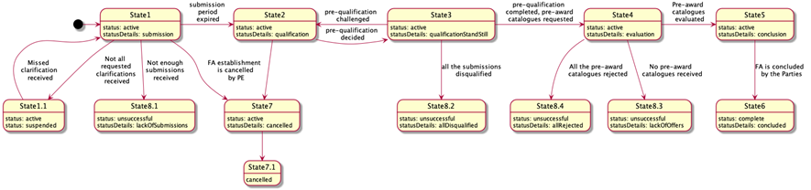

Figure 25 – State-chart diagram for the conclusion of a FA

OCDS dataset

**Announcement of the initiation of the FA**

The announcement of the initiation of a FA is made through the publication of a CN that provides:

* General procurement information;
* list of products and categories included in the FA;
* minimum technical specifications;
* lots, where applicable;
* fixed and non-fixed terms and conditions;
* duration of the FA;
* limitations on the number of suppliers, where applicable;
* qualification criteria and techniques.

Call for enquiries

In order to indicate the start date and the end date of the explanatory phase of a procurement process established by a CA, a separate enquiryPeriod object must be added into the tender building block which will reflect the end date indicated by the CA, and its start date will reflect the moment of initiation of the explanatory phase in the system:

|  |
| --- |
| {  "tender": {  "enquiryPeriod": {  "startDate": "",  "endDate": ""  }  }  } |

Figure 26 – Enquiry period

Call for enquiries

The pre-qualification phase shall be launched in order to receive requests for participation from interested EOs. The following options must be taken into consideration:

* Pre-qualification establishment: A separate preQualification block shall be included into the Contract Notice where preliminary qualification or selection of the candidates to be invited to submit an offer is needed.

|  |
| --- |
| {  "preQualification": {  "id": "",  "status": "",  "procuringEntity":{}  }  } |

Figure 27 – PreQualification

* Call for EoI: Submission of EoIs is only available during a certain period determined in the stage of pre-qualification. In order to reflect such a period, a separate object period must be added into the preQualification block.

|  |
| --- |
| {  "preQualification": {  "period": {  "startDate": "",  "endDate": ""  }  }  } |

Figure 28 – Period for submission of EoIs

A PAC request can also be published, as will be later on described.

State1 - Submission phase (active.submission)

**Enquiries - requests and clarifications**

During the enquiry period (tender.enquiryPeriod), any interested EO is allowed to send enquiries, that is, requests for clarification. Such requests remain anonymous until tender.enquiryPeriod.endDate. After tender.enquiryPeriod.endDate, no more enquiries can be received.

* Enquiries: All the enquiries received within the tender.enquiryPeriod must be disclosed inmediately as an enquiries array item. Enquiries authors remain confidential until the start of the evaluation.

|  |
| --- |
| {  "tender": {  "enquiries": [  {  "id": "",  "title": "",  "description": "",  "relatedLot": ""  }  ]  }  } |

Figure 29 – Enquiries

* Answers: During enquiryPeriod, the CA is able to submit an answer to each question received.

|  |
| --- |
| {  "tender": {  "enquiries": [  {  "id": ""  "answer": "",  "dateAnswered": ""  }  ]  }  } |

Figure 30 – Answers to enquiries

**Submission of EoI**

The submission of EoIs is only allowed during a specific period of time, determined by the pre-qualification stage. In order to reflect this period, a separate period object can be added into the preQualification block, where the specific timeframe for EoIs is determined. Thus, within a given preQualification.period any interested EO is allowed to send a submission, that is, a request for participation or EoI. Each request shall fulfil all the requirements set by the CA, providing an array of requirementResponses.

Having a set of requirements predefined by the CA and a number of values available for each requirement, EOs shall specify a value for each requirement and fulfil general corporate profiles’ data as requested by the CA or required by the Legal Framework of a particular jurisdiction.

Thus, each EoI includes:

1. An organisation profile according to the extended ‘organisation’ model;
2. a set of documents of the tender, specified with relevant types of documents for their future splitting into the different "envelopes";
3. a set of required responses according to criteria specified by the CA within the CN:

* Commitment on exclusion grounds;
* commitment on selection criteria (including absolute values if required);
* commitment on minimum technical requirements (including absolute values if required).

|  |
| --- |
| {  "submission": {  {  "id": "1",  "requirementResponses": [  {  "id": "",  "value": "true",  "requirement": {},  "relatedCandidate": {}  },  {  "id": "",  "value": "true",  "requirement": {},  "relatedCandidate": {}  }  ],  "candidates": [  {}  ]  }  }  } |

Figure 31 – Submission of EoI

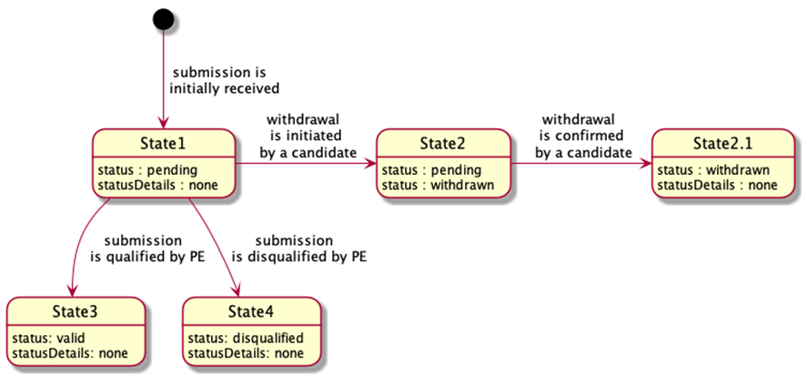

Figure 32 – State-chart diagram for submission of EoIs

All the submissions received remain confidential and closed until the expiration of the period for submission (preQualification.period.endDate). Once the deadline for submissions is reached, no submissions can be received, withdrawn or corrected.

State1.1 - Suspension due to non-clarification (active.suspended)

When initiation is suspended, a particular value for tender.statusDetails is used:

|  |
| --- |
| {  "tender":{  "statusDetails": "suspended"  }  } |

Figure 33 – Status of the tender

State8.1 - Unsuccessful completion of submission (unsuccessful.lackOfSubmissions)

If not enough submissions were collected during the EoI period, the pre-qualification phase will end unsuccessfully, with no future actions by the CA. The procurement initiation shall be moved to a phase of preparation of a negative notice.

**Submission of EoI**

The result of the pre-qualification must be reflected with preQualification.status:

* complete when enough candidates were selected for future invitation to submit a tender;
* unsuccessful when pre-qualification is unsuccessfully completed due to lack of submissions or because all the submissions were disqualified.

|  |
| --- |
| {  "preQualification": {  "status": ""  }  } |

Figure 34 – Status of the preQualification

**Indication of the unsuccessful outcome of a procurement initiation**

* For lots: A negative outcome of procurement under a specific lot is reflected with lot.status: unsuccessful, when the lot is closed unsuccessfully due to a lack of submissions for pre-qualification or tenders for evaluation, or when all the tenders were rejected;

|  |
| --- |
| {  "lots": [  {  "status": "unsuccessful"  }  ]  } |

Figure 35 – Unsuccessful status at lot level

* For entire initiation: A negative outcome of a procurement under an entire initiation (procurement process) is reflected with tender.status: unsuccessful, when initiation is closed unsuccessfully due to a lack of submissions for pre-qualification or tenders for evaluation, or where all the tenders were rejected. Details of a negative closure are reflected in tender.statusDetails:
* lackOfSubmissions
* allDisqualified
* lackOfOffers
* allRejected

|  |
| --- |
| {  "tender": {  "status": "unsuccessful",  "statusDetails": ""  }  } |

Figure 36 – Unsuccessful status at tender level

State2 - Qualification phase (active.qualification)

**Initiation of Qualification phase**

* Disclosure of the submissions: When there are enough submissions, all the submissions are disclosed as a submissions array. All the submissions’ authors are added into parties as organizations with a role: candidate.

|  |
| --- |
| {  "submissions": {  "details": [  {  "id": "1",  "requirementResponses": [  {  "id": "",  "value": "true",  "requirement": {},  "relatedTenderer": {}  },  {  "id": "",  "value": "true",  "requirement": {},  "relatedTenderer": {}  }  ],  "tenderers": [  {}  ]  }  ]  }  } |

Figure 37 – Disculosure of submissions

* Establishment of a period for qualification by the CA: In order to indicate a start of the qualification phase of a procurement process, a start date must be established adding a separate qualificationPeriod object into the preQualification building block, which will reflect a start date of the qualification phase as a system moment:

|  |
| --- |
| {  "submissions": {  "details": [  {  "preQualification": {  "qualificationPeriod": {  "startDate": ""  }  }  } |

Figure 38 – Period for Qualification

* Qualification envelopes: Along with the establishment of preQualification.qualificationPeriod.startDate, a set of qualifications is established against each submission received in order to allow the CA to reflect its decision on each submission. Such objects, based on Qualifications schema, are initially established with status:pending  and statusDetails:awaiting (*State 1* of a qualification object). Since no order is prescribed for the pre-qualification sequence, the CA can evaluate submissions received randomly.

|  |
| --- |
| {  "qualifications": [  {  "id": "",  "status": "pending",  "statusDetails": "awaiting",  "candidates": [],  "relatedSubmission": ""  }  ]  } |

Figure 39 – Status of the Qualification

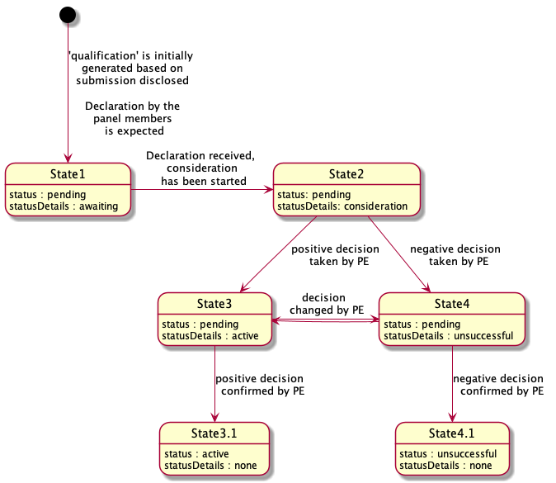

Figure 40 – State-chart diagram for Qualification

**Declaration of non-conflict of interest**

Before starting qualification, each declared member of the Evaluation Panel shall respond with a confirmation of absence of conflict of interest against each candidate from each qualification by sending relevant requirementResponses according to a common flow for declaration.

* Request of declaration: Since the declaration is the same for all members of the Evaluation Panel (either single procurement officers or all the members), it can be designed as a common requirement under specific criteria, related to the organisation appointed as a CA:

|  |
| --- |
| {  "tender": {  "criteria": [  {  "id": "",  "title": "Declaration of absence of conflict of interest and confidentiality",  "relatesTo":"procuringEntity",  "requirementGroups": [  {  "id": "",  "requirements": [  {  "id": "",  "description": "I am aware of Article 24 of Directive 2014/24/EU on public procurement, which states that: ‘The concept of conflicts of interest shall at least cover any situation where staff members of the contracting authority or of a procurement service provider acting on behalf of the contracting authority who are involved in the conduct of the procurement procedure or may influence the outcome of that procedure have, directly or indirectly, a financial, economic or other personal interest which might be perceived to compromise their impartiality and independence in the context of the procurement procedure.’\nto the best of my knowledge and belief I have no conflict of interest with the operators who have submitted a tender for this procurement, including persons or members of a consortium, or with the subcontractors proposed;\nthere are no facts or circumstances, past or present, or that could arise in the foreseeable future, which might call into question my independence in the eyes of any party;\nif I discover during the course of the [project/evaluation] that such a conflict exists or could arise, I will inform the contracting authority without delay;\nI am encouraged to report a situation or risk of conflict of interest as well as any type of wrongdoing or fraud (i.e. whistleblowing), and if I do so, I should not be treated unfairly or be sanctioned;\nI understand that the contracting authority reserves the right to verify this information.",  "dataType": "boolean"  },  {  "id": "",  "description": "I confirm that I will keep all matters entrusted to me confidential. I will not communicate outside the [project team/evaluation committee] any confidential information that is revealed to me or that I have discovered. I will not make any adverse use of information given to me.",  "dataType": "boolean"  }  ]  }  ]  }  ]  }  } |

Figure 41 – Request of declaration

* Declaration: Now each declared member of the Evaluation Panel can respond with a confirmation of absence of conflict of interest against each tenderer from each award (in case of a combined evaluation under single-stage procurement) or each candidate from each qualification (in case of a multi-stage procurement with prior qualification) by sending the relevant requirementResponses.

|  |
| --- |
| {  "awards": [ // "qualifications" for multi-stage procurement with prior qualification  {  "id":"",  "requirementResponses":[  {  "id":"",  "value":true,  "requirement":{  "id":"",  "description":""  },  "relatedTenderer":{  "id":"",  "name":""  },  "responder":{  "id":"",  "name":""  }  },  {  "id":"",  "value":true,  "requirement":{  "id":"",  "description":""  },  "relatedTenderer":{  "id":"",  "name":""  },  "responder":{  "id":"",  "name":""  }  }  ]  }  ]  } |

Figure 42 – Declaration

**Qualification of submissions**

Once all the non-conflict of interest declarations are submitted by Evaluation Committee members, the qualification for review is switched into qualification.statusDetails: consideration (State 2 of a relevant state-chart diagram of a qualification object).

* Consideration: The CA shall update qualification with all the required meta-data. By updating, the CA reflects its decision on each submission received. The CA is allowed to:
  + Add any qualification.documents if needed;
  + add qualification.requirementResponses if any relevant requirements related to the CA within the pre-qualification phase prescribed by criteria is applied;
  + add text qualification.descriptions where any justification is needed;
  + add qualification.date when any decision was taken;
  + add qualification.internalID, if any.
* Indication of a decision: Once consideration of a specific submission is complete and the related qualification is fully updated with all relevant data, the CA shall change the qualification state, reflecting a positive or negative decision in this regard:
  + qualification.statusDetails: active - state 3 of a relevant state-chart diagram of a qualification object. This means the submission is qualified and a candidate(s) will be invited to submit a commercial tender.
  + qualification.statusDetails: unsuccessful - state 4 of a relevant state-chart diagram of a qualification object. This means the submission is disqualified.

|  |
| --- |
| {  "qualifications": [  {  "id": "",  "internalid":"",  "date":"",  "status": "pending",  "statusDetails":"active"  "documents":[],  "requirementResponses":[],  "candidates": [],  "relatedSubmission": ""  },  {  "id": "",  "internalid":"",  "date":"",  "status": "pending",  "statusDetails":"unsuccessful",  "description":"This is why this candidates' submission was rejected"  "documents":[],  "requirementResponses":[],  "candidates": [],  "relatedSubmission": ""  }  ]  } |

Figure 43 – Qualification of submissions

As soon as the CA has completed the qualification and all the submissions received are updated with the relevant meta-data, the CA indicates the end of qualification.

State3 - Standstill period for pre-qualification (active.qualificationStandStill)

In this state, no one can take any action except the CA to switch the process to State4 or back to State2. No other actions can be prescribed for the system - all review procedures go offline and the time tracking is up to the CA.

**Completion of qualification period**

If no blockers are indicated during the stand-still period, the CA can initiate the end of the qualificationPeriod and the entire pre-qualification phase. Additional values of the endDate can be added into the preQualification.qualificationPeriod as an indication of pre-qualification completion.

|  |
| --- |
| {  "preQualification": {  "qualificationPeriod": {  "endDate": ""  }  }  } |

Figure 44 – Qualification period

**Finalization of pre-qualification**

* Finalization of the qualifications: All the qualifications shall be moved into relevant final statuses:
  + qualification.status: pending / statusDetails: active → qualification.status: active / statusDetails: none *(*State 3 to State 3.1 of a relevant state-chart diagram of a qualification object. Means that the submission is qualified and the candidate is invited to submit a tender);
  + qualification.status: pending / statusDetails: unsuccessful → qualification.status: unsuccessful / statusDetails: none (State 4 to State 4.1 of a relevant state-chart diagram of a qualification object. Means that the submission is disqualified).
* Finalization of the submissions: All the related submissions are assigned the relevant statuses:
  + submission.status: pending where relevant qualification.status: active → submission.status: valid (State 1 to State 3 of a relevant state-chart diagram of a submission);
  + submission.status: pending where relevant qualification.status: unsuccessful → submission.status: disqualified (State 1 to State 4 of a relevant state-chart diagram of a submission).

**Completion of pre-qualification**

The result of the pre-qualification must be reflected with preQualification.status:

* complete where enough candidates were selected for future invitation to submit a tender;
* unsuccessful where pre-qualification is unsuccessfully completed due to a lack of submissions or because all the submissions were disqualified.

|  |
| --- |
| {  "preQualification": {  "status": ""  }  } |

Figure 45 – PreQualification status

State8.2 - Unsuccessful completion of pre-qualification (unsuccessful.allDisqualified)

Where all the submissions collected during the EoI period were disqualified, the pre-qualification phase will end unsuccessfully with no future actions by the CA. Procurement initiation shall be moved to a phase of preparation of a negative notice.

**Completion of qualification period**

If no blockers are indicated during the stand-still period, the CA can initiate the end of the qualificationPeriod and the entire pre-qualification phase.

An additional value of endDate is added into preQualification.qualificationPeriod as an indication of pre-qualification completion.

|  |
| --- |
| {  "preQualification": {  "qualificationPeriod": {  "endDate": ""  }  }  } |

Figure 46 –Qualification period

**Finalisation of pre-qualification**

The result of the pre-qualification is reflected with preQualification.status:

* complete where enough candidates were selected for future invitation to submit a tender;
* unsuccessful where pre-qualification is unsuccessfully completed due to a lack of submissions or because all the submissions were disqualified.

|  |
| --- |
| {  "preQualification": {  "status": ""  }  } |

Figure 47 –PreQualification status

**Indication of the unsuccessful outcome of procurement initiation**

* For lots: A negative outcome of a procurement under a specific lot is reflected with lot.status: unsuccessful where the lot is closed unsuccessfully due to a lack of submissions for pre-qualification or tenders for evaluation, or where all the tenders were rejected.

|  |
| --- |
| {  "lots": [  {  "status": "unsuccessful"  }  ]  } |

Figure 48 –Unsuccessful outcome at lot level

* For entire initiation: A negative outcome of a procurement under entire initiation (procurement process) is reflected with tender.status: unsuccessful, where initiation is closed unsuccessfully due to a lack of submissions for pre-qualification or tenders for evaluation, or where all the tenders were rejected. Details of a negative closure are reflected in tender.statusDetails:
  + lackOfSubmissions
  + allDisqualified
  + lackOfOffers
  + allRejected

|  |
| --- |
| {  "tender": {  "status": "unsuccessful",  "statusDetails": ""  }  } |

Figure 49 –Unsuccessful outcome at tender level

State4 - Evaluation (active.evaluation)

This state means that pre-qualification has been conducted and technical offers requested through a call for proposals sent to the candidates selected by the CA. In case of FAs, such a call shall be implemented via publication of PAC requests either together with the publication of the FA or once pre-qualification is performed, as will be later on detailed.

In any case, the FA remains in a ‘stand-by’ mode until tenderPeriod expires for all issued PAC requests.

State5 - Conclusion of a FA

Once evaluation is performed by the CA for each issued PAC request and a set of purchasing items is identified for each invited candidate, the FA can be concluded. All the purchasing items under the FA, together with any information related to agreed metrics of performance and conditions of execution for each selected EO, shall be collected.

To describe and reflect the parties of a concluded FA, a common inclusive contract object shall be added to a FA conclusion record:

|  |
| --- |
| "contracts": [  {  "id": "",  "indernalId": "",  "description": "",  "status": "",  "statusDetails": ""  "period": {  "startDate": "",  "endDate": ""  },  "suppliers": [],  "isFrameworkOrDynamic": false  }  ] |

Figure 50 –Conclusion of a FA

Such an object reflects:

* Requisites of the FA;
* period and duration;
* list of selected EOs.

To reflect the scope of the FA, together with all metrics agreed by the parties, a set of framework contracts concluded as a result of PAC requests shall be listed using a relatedProcesses array:

|  |
| --- |
| "contracts": [  {  "relatedProcesses":[  {  "id":"",  "relationship":[  "x_frameworkContract"  ],  "scheme":"ocid",  "identifier":"",  "uri":""  }  ]  }  ] |

Figure 51 –Scope of the FA

State6 - Completion of a procedure

Indication of the successful outcome of procurement initiation:

* For lots: Positive outcome of a procurement under a specific lot must be reflected with lot.status: complete.

|  |
| --- |
| {  "lots": [  {  "status": "complete"  }  ]  } |

Figure 52 –Successful outcome at lot level

* For entire initiation: Positive outcome of a procurement under the entire initiation (procurement process) must be reflected with tender.status: complete.

|  |
| --- |
| {  "tender": {  "status": "complete"  }  } |

Figure 53 –Successful outcome at tender level

Pre-award catalogue request

A PAC request under a FA can be issued when:

* All terms and conditions of the procurement are established with the conclusion of the FA, that is, when the CA has enough information from the beginning of the process. In this case, the issuing of the PAC goes together with the publication of the CN of the FA;
* the CA doesn't have enough information or is not willing to disseminate the details before the conclusion of the FA. In this case, the issuing of the PAC goes right after the pre-qualification phase, once the EOs have already been selected.

State-chart diagram

The sequence of a stages applicable for a PAC request is the following:

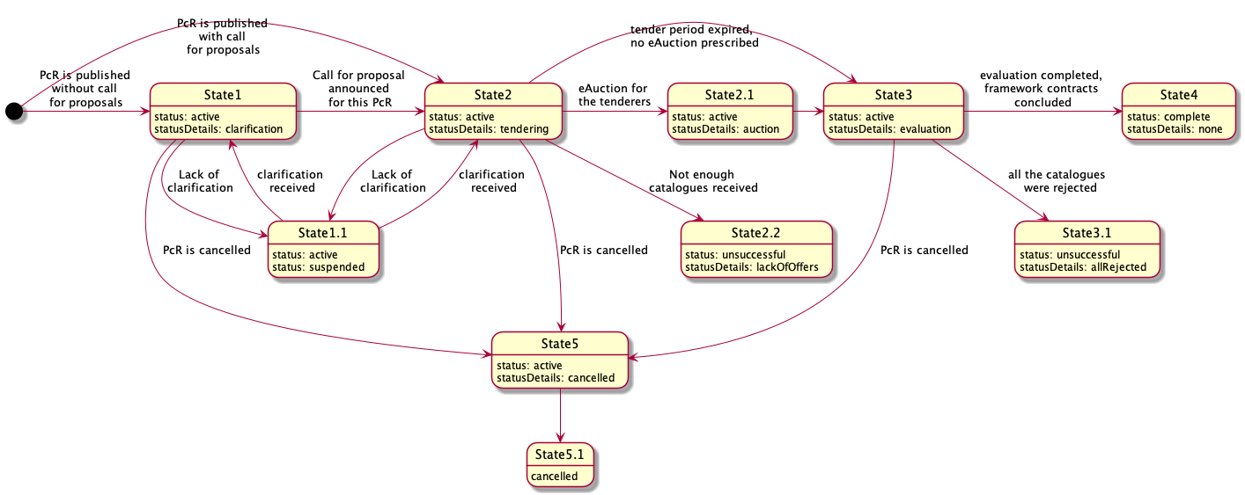

Figure 54 – State-chart diagram for a PAC request

OCDS dataset

**Issuing of a PAC request**

The PAC request within a FA shall include:

* List of products category determined for this request;
* minimum technical specification or a specific nomenclature, where applicable;
* lots, where applicable;
* fixed and non-fixed terms and conditions;
* awarding mechanisms and evaluation criteria and techniques.

**State1 - Clarification (active.clarification)**

In the case of publication of a PAC request (for informational purposes and for discussion but without call for proposals), the CA shall initiate a period for clarifications for all the interested EOs.

Call for enquiries

In order to indicate a start of the explanatory phase of a procurement process, the CA shall establish a start date as an enquiry session. Such an indication shall be done by adding a separate enquiryPeriod object into the tender building block, which will reflect the end date indicated by the CA and its start date will reflect the moment of initiation of the explanatory phase in the system:

|  |
| --- |
| {  "tender": {  "enquiryPeriod": {  "startDate": "",  "endDate": ""  }  }  } |

Figure 55 – Enquiry period

**State2 - Tendering (**active.tendering**)**

Either after the clarification phase (State1) or together with the publication of the PAC request, the CA shall initiate a period for submission of the PAC by either any interested EO or invited candidates.

Call for proposals

In order to indicate the start of the tendering phase of a procurement process, the CA shall establish a start date for the tendering period during which interested EOs will be able to submit their tenders. This shall be done by adding a separate tenderPeriod object into the tender building block which will reflect the end date indicated by the CA and its start date will reflect the moment of initiation of the tendering phase in the system:

|  |
| --- |
| {  "tender": {  "tenderPeriod": {  "startDate": "",  "endDate": ""  }  }  } |

Figure 56 – Tender period

When the call for proposals is to be published together with the publication of a PAC request, call for enquiries is supposed to be included into the same period of time but as a separate object as described above.

Tendering

Each invited EO is allowed to submit a tender within the given tender.tenderPeriod indicated with the call for proposals. Each tender must be based on a bids schema and shall fulfil all the requirements prescribed by the criteria related to items or lots with a relevant list of the responses provided by the EO (confirmative or quantifiable according to available values by applied PQQ) by providing an array of requirementResponses.

Having a set of requirements predefined by the CA and a number of values available for each requirement, EOs shall specify a value for each requirement and fulfil general corporate profiles’ data as requested by the CA or required by the Legal Framework of a particular jurisdiction.

Thus, each offer includes:

1. An organisation profile according to the extended ‘organisation’ model (or a reference on such profile previously sent while submitting an EoI, in the case of two-stage procedures);
2. set of documents of the tender, specified with relevant types of documents for their future splitting into the different "envelopes";
3. absolute financial value of the tender;
4. decomposed array of unit prices (when requested by the CA);
5. set of required responses according to criteria specified by the CA within the CN:

* Responses on requirements regarding the nature of the subject-matter of procurement;
* responses on requirements regarding the nature of the delivery and post-delivery.

|  |
| --- |
| {  "bid": {  "id": "",  "status": "",  "relatedLots": [],  "tenderers":[],  "items": [  {  "id": "",  "description": "",  "quantity": "",  "unit": {},  "relatedLot":""  }  ],  "requirementResponses":[]  }  } |

Figure 57 – Bid information

All the tenders collected remain confidential and closed until the expiration of the tendering period, tender.tenderPeriod.endDate. After tender.tenderPeriod.endDate, no tenders can be received, withdrawn or corrected.

**State2.2 - Unsuccessful completion of tendering (**unsuccessful.lackOfOffers**)**

Where not enough bids were collected during the tendering period for all lots, the evaluation phase will end in an unsuccessful way with no future actions by the CA. Procurement initiation shall be moved to a phase of preparation of a negative notice.

Indication of the unsuccessful outcome of procurement initiation

* For lots

A negative outcome of procurement under a specific lot is reflected with lot.status: unsuccessful, where the lot is closed unsuccessfully due to a lack of submissions for pre-qualification or tenders for evaluation, or where all the tenders were rejected.

|  |
| --- |
| {    "lots": [      {        "status": "unsuccessful"      }    ]  } |

Figure 58 – Unsuccessful lot

* For entire initiation (tender)

A negative outcome of a procurement under an entire initiation (procurement process) is reflected with tender.status: unsuccessful, where initiation is closed unsuccessfully due to a lack of submissions for pre-qualification or tenders for evaluation, or where all the tenders were rejected. Details of a negative closure are reflected in tender.statusDetails

* lackOfSubmissions
* allDisqualified
* lackOfOffers
* allRejected

|  |
| --- |
| {    "tender": {      "status": "unsuccessful",  "statusDetails": ""    }  } |

Figure 59 – Unsuccessful tender

**State3 - Evaluation (**active.evaluation**)**

Initiation of evaluation phase

* Disclosure of the proposals

Where enough bids are received, all tenders are disclosed as a bids array. All authors (bid.tenderers) are updated into parties as organizations with role: tenderer.

|  |
| --- |
| {  "bids": {  "details":[  {  "id": "",  "status": "pending",  "statusDetails":""  "relatedLots": [],  "tenderers":[],  "items": [  {  "id": "",  "description": "",  "quantity": "",  "unit": {},  "relatedLot":""  }  ],  "requirementResponses":[]  }  }  ]  } |

Figure 60 – Disclosure of bids

* Establishment of a period for evaluation

A separate object awardPeriod is added into a tender block where the specific startDate for awarding is determined automatically. Such block is based on a Period schema

|  |
| --- |
| {  "tender": {  "awardPeriod": {  "startDate": ""  }  }  } |

Figure 61 – Award period

* Evaluation envelopes

Along with tender.awardPeriod.startDate, a set of all tenders received during prior tendering phase must be disclosed using a bids array according to the relevant schema. All the bids authors (referring to final offers) must be updated into parties with a role: tenderer. Such objects are based on the Awards schema and are initially established with status:pending and statusDetails:none. All authors of submissions (referring to EoI or ESPD or other related documentation aimed at the qualification of the EO) must be added into parties as organizations with role: candidate.

|  |
| --- |
| {  "awards": [  {  "id": "",  "status": "pending",  "suppliers": [],  "relatedLots": [],  "relatedBid": ""  }  ]  } |

Figure 62 – Evaluation

* Disclosure of the enquirers

Together with the initiation of the evaluation phase, all the enquirers (tender.enquiries[*].author) must be reflected into a parties array with role: enquirer, once the tender.enquiryPeriod.endDate is achieved.

Initial ranking on award criteria

Depending on tender.awardCriteria and tenderAwardCriteriaDetails, an initial automated ranking can or cannot be done on:

|  |  |  |  |  |
| --- | --- | --- | --- | --- |
| **awardCriteriaDetatils / awardCriteria** | **priceOnly** | **costOnly** | **qualityOnly** | **ratedCriteria** |
| automated | bid.value | bid.requirementResponses * lot.value | bid.requirementResponses * 1 | bid.requirementResponses * bid.value |
| manual |  |  |  |  |

Table 18 – Award criteria

As shown in the table above, automated ranking can be undertaken automatically using a set of criteria and the relevant conversions applied by the CA for each available value of each applied requirement  published in a CN, on one hand; and the bid.requirementResponses  submitted by each EO against published criteria, on the other hand. These two data-sets allow the normalised value for each bid based on the same approach.

* Normalised price

Where normalised price must be calculated, the following formula is applied for each tender in order to identify which one is most suitable by normalised price:

*Pn = P * C1 * C2 * ... Cn*

where:

* + Pn - value of normalised price
  + P - basic price taken from bid.value or lot.value  or equal to '1' depending on awardCriteria
  + C1 ... Cn - values of the coefficients to be applied (related with values of requirements, available for EO and indicated in requirementResponses)
* Ranking approach
  + Where awardCriteria: priceOnly, only bid.value is to be compared in order to identify the most suitable tender - cheapest goes first;
  + where awardCriteria: costOnly, assumption is that all the tenderers have the bid.value equal to lot.value. This means that the normalised price needs to be calculated for each bid  received, based on an estimated value lot.value - cheapest goes first;
  + where awardCriteria: qualityOnly, assumption is that the price doesn't matter and the only valuable part of the tender is the quality, meaning the set of values of criteria, selected by the EO while submitting a tender. This means that the normalised price needs to be calculated for each bid  received, based on '1';
  + where awardCriteria: ratedCriteria, assumption is that both price and quality matter. This means that the normalised price needs to be calculated for each bid  received based on 'bid.value'.

Where automated ranking is the case, all the awards are ranked into order for evaluation and the first award (most suitable according to the prescribed evaluation function) will be switched to the next state ‘available for evaluation’ by the CA.

Depending on previously established or not established eligibility check, this state may be:

* award.statusDetails: consideration - where eligibility check took place previously;
* award.statusDetails: awaiting - where eligibility check was not conducted previously by the CA.

Consideraton

* Evauation

To evaluate the award (tender), the CA shall update it with all the required meta-data. In these updates, the CA is allowed to:

* + Add any documents  if needed;
  + Add requirementResponses if there are any relevant requirements  related to the CA within the evaluation phase prescribed by tender.criteria;
  + Add text descriptions  where any justification is needed;
  + Add date  when the decision was taken;
  + Add internalID if any.
* Indication of a decision

Once the evaluation of a specific tender is complete and the related award is fully updated with all relevant data, the CA shall switch the award to one of the states, reflecting a positive or negative decision:

* award.statusDetails: active - means the related bid is selected as a winning tender to be awarded;
* award.statusDetails: unsuccessful - means the related bid is rejected.

|  |
| --- |
| {  "awards": [  {  "id": "",  "description": "",  "status": "pending",  "date": "active",  "suppliers": [],  "relatedLots": [],  "relatedBid": "",  "documents": [],  "requirementResponses": [],  "indernalId": ""  }  ]  } |

Figure 63 – Awards

As soon as the CA has completed the evaluation and the winning candidates for a particular lot are identified or all the proposals under this lot are rejected, the CA indicates the end of evaluation of the lot by publishing an intention to award a contract (award decision).

Award decision

To reflect a decision regarding each specific lot and the proposal selected to be awarded with a contract (award.statusDetails:active), the CA prepares a Notice on Award Decision. This data-entity is included in a contracts array.

Since it is a stand-still period for evaluation, initially these contracts are established with a status: pending and statusDetails which reflects a decisions' result:

* contract.statusDetails: active where the decision regarding the lot is positive (winner is identified);
* contract.statusDetails: unsuccessful where the decision regarding the lot is negative (all the tenders were rejected).

|  |
| --- |
| {    "contracts": [      {        "id": "",  "date": "",  "awardId": "",  "status": "pending",  "statusDetails": "awaiting",      }    ]  } |

Figure 64 – Contracts

Stand-still period

In this state, no one can take any actions except the CA, who switches the process to State4 or back to State2. No other actions can be prescribed for the system - all review procedures go offline, and the time tracking is up to the CA.

Cancellation of the award decision

To reflect a decision to cancel a specific award decision taken previously under a particular lot, the CA shall switch the relevant contract object into contract.status: cancelled

|  |
| --- |
| {    "contracts": [      {        "status": "cancelled"      }    ]  } |

Figure 65 – Cancelled contract

Confirmation of the award decisions

If no blockers indicated during stand-still period, the CA can initiate contract preparation for the awarded lot or finalization of an unsuccessful output of a lot where all the proposals were rejected during the evaluation phase.

* Confirmation of a negative award decision

Confirmation of a negative award decision requires switching the relevant contract object to final status:unsuccessful, with a parallel indication of the reason for a negative outcome as a statusDetails:

|  |
| --- |
| {  "contracts" : [  {  "id":"",  "awardId":"",  "status":"unsuccessful",  "statusDetails": "allOffersRejected"  }  ]  } |

Figure 66 – Unsuccessful contract

* Confirmation of a positive award decision

Confirmation of a positive decision requires reflecting the subsequent contract initiation into a relevant contract object by indicating statusDetails, provided that the object remains intermediate status: pending

|  |
| --- |
| {  "contracts" : [  {  "id":"",  "awardId":"",  "status":"pending",  "statusDetails": "contractPreparation"  }  ]  } |

Figure 67 – Status “Pending”

Contract initiation

To describe and reflect the scope of a contract to be concluded on a positive award decision, a parallel data-stream will be initiated. This stream is a separate OCDS-record where all the information related to future contracts is collected from a current procurement process. In order to establish the relation with this parallel stream, the relevant contract reflects a positive award decision and shall be extended with a relatedProcess.relationship: [x_contracting]:

|  |
| --- |
| {  "contracts" : [  {  "id":"",  "awardId":"",  "status":"pending",  "statusDetails": "contractPreparation",  "relatedProcesses": [  {  "id": "",  "relationship": [  "x_contracting"  ],  "scheme": "ocid"  }  ]  }  ]  } |

Figure 68 – Contract initiation

**State3.1 - Unsuccessful completion of evaluation (**unsuccessful.lackOfOffers**)**

Where all the bids collected during the period of tendering were rejected, the evaluation phase will end unsuccessfully with no future actions by the CA.

Indication of the unsuccessful outcome of procurement initiation

* For lots

A negative outcome of procurement under a specific lot is reflected with lot.status: unsuccessful, where the lot is closed unsuccessfully due to a lack of submissions for pre-qualification or tenders for evaluation, or where all the tenders were rejected.

|  |
| --- |
| {    "lots": [      {        "status": "unsuccessful"      }    ]  } |

Figure 69 – Unsuccessful lot

* For entire initiation (tender)

A negative outcome of a procurement under the entire initiation (procurement process) is reflected with tender.status: unsuccessful, where the initiation is closed in a negative way due to a lack of submissions for pre-qualification or tenders for evaluation, or where all the tenders were rejected. The details of a negative closure are reflected in tender.statusDetails.

* + lackOfSubmissions
  + allDisqualified
  + lackOfOffers
  + allRejected

|  |
| --- |
| {    "tender": {      "status": "unsuccessful",  "statusDetails": ""    }  } |

Figure 70 – Unsuccessful tender

**State4 - Completion of procedure**

Indication of the successful outcome of procurement initiation

* For lots

A positive outcome of a procurement under a specific lot is reflected with lot.status: complete.

|  |
| --- |
| {    "lots": [      {      "status": "complete"      }    ]  } |

Figure 71 – Successful lot

* For entire process

A positive outcome of a procurement under an entire initiation (procurement process) is reflected with tender.status: complete.

|  |
| --- |
| {    "tender": {      "status": "complete"    }  } |

Figure 72 – Successful tender

## Execution of a FA

When a FA has been concluded with more than one EO, that FA shall be performed in one of the following ways by the CA or the CPB:

* Following the terms and conditions of the FA, without the reopening competition, by awarding a contract directly to a specific EO applying the terms governing the provision of the works, services and supplies concerned and the objective conditions set in the FA;
* Where not all the terms governing the provision of the works, services and supplies are laid down in the FA, through reopening competition amongst the EOs parties to the FA;
* Partly without reopening of competition and partly with reopening of competition amongst the EOs parties to the FA, where this possibility has been stipulated in the procurement documents for the FA.

State-chart diagrams

Direct purchase

The following diagram presents the sequence of stages applicable for the execution of a FA based on direct purchase following the terms and conditions of the FA, without reopening competition, by awarding a contract directly to a specific EO applying the terms governing the provision of the works, services and supplies concerned and the objective conditions set in the FA:

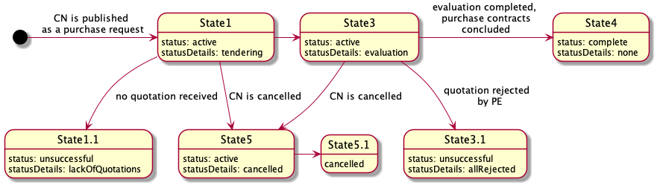

Figure 73 – State-chart diagram for direct purchase under a FA

Mini-competition

The following diagram presents the sequence of stages applicable for the execution of a FA based on reopening of competition (partially or completely) amongst the EOs parties to the FA:

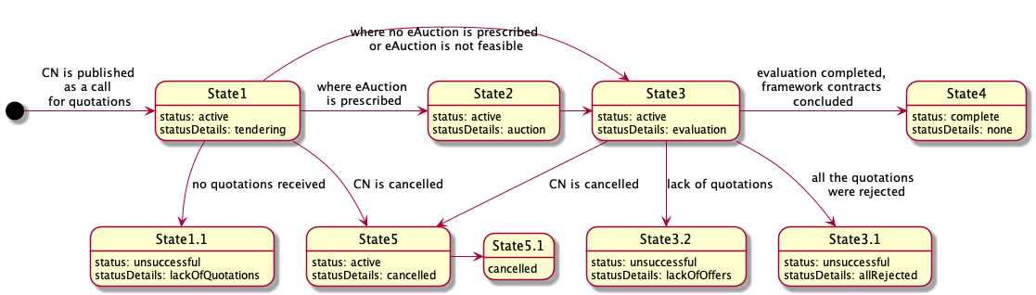

Figure 74 – State-chart diagram for mini-competition under a FA

Further detail on the different statuses is provided later on in this document.

OCDS dataset

Issuing of a Direct purchase under a FA

This request shall be formed on the basis of the FA execution and include:

* Products category determined for this request;
* precise technical specification;
* lots (where applicable);
* specific nomenclature;
* terms and conditions which are non-fixed in the (if any);
* evaluation criteria.

|  |
| --- |
| {  "tender": {  "id": "",  "classification": {},  "status": "",  "targets": "",  "criteria": [],  "conversions": [],  "awardCriteria": "",  "awardCriteriaDetails": "",  "lots": [],  "items": [  {  "id": "",  "description": "",  "relatedLot": "",  "deliveryAddress": {},  "quantity": "",  "unit": {}  }  ]  }  } |

Figure 75 – Code for issuing of a Direct purchase under a FA

Issuing of a Mini-competition under a FA

This request shall be formed on the basis of the FA execution and include:

* products category determined for this request;
* minimum technical specification (where applicable);
* lots (where applicable);
* specific nomenclature;
* terms and conditions which are non-fixed in the FA (if any);
* awarding methodology and evaluation criteria and techniques.

|  |
| --- |
| {  "tender": {  "id": "",  "classification": {},  "status": "",  "targets": "",  "criteria": [],  "conversions": [],  "awardCriteria": "",  "awardCriteriaDetails": "",  "procurementMethodModalities": [],  "lots": [],  "items": [  {  "id": "",  "description": "",  "relatedLot": "",  "deliveryAddress": {},  "quantity": "",  "unit": {}  }  ]  }  } |

Figure 76 – Code for issuing a Mini-competition under a FA

OCDS dataflow

Direct purchase

**State1 - Tendering (active.tendering)**

Together with the publication of the Purchase Request (PR), the CA shall initiate a period for the response by a quoted party of the FA.

* **Purchase request**

In order to indicate the initiation of the period for the quoted party of a FA to respond to a PR, the CA shall establish the start and end dates of such period. This shall be done by adding a separate tenderPeriod object into the tender building block, which will reflect the end date of the period for response prescribed by the CA and its start date, reflected as a system moment of initiation of the tendering phase:

|  |
| --- |
| {  "tender": {  "tenderPeriod": {  "startDate": "",  "endDate": ""  }  }  } |

Figure 77 – Code for establishing the period of a Purchase request

* **Response to the purchase request**

The EO that is party to the FA is the only one allowed to submit a quotation within the given tender.tenderPeriod indicated in a PR:

* Quotation is based on Bids schema.
* Quotation shall fulfil all the requirements prescribed by Criteria related to items or to lots with a relevant list of the responses by the EO, providing an array of requirementResponses.

Having a set of requirements predefined by the CA and a number of values available, the EO preparing a submission includes values for each requirement, reflecting the substance of the quotation and fulfilling general corporate profiles’ data, as requested by the CA or required by the legal framework of a particular jurisdiction.

Each offer includes:

1. An organization profile according to the extended Organization model (or a reference to such a profile previously sent within the FA);
2. a set of documents of the tender, specified with relevant types of documents for their future splitting into the different "envelopes";
3. absolute financial value of the tender;
4. a set of required responses according to the criteria specified by the CA within the Contract Notice (CN) related to the financial part of the offer:

* reflections on requirements characterise the nature of the subject of procurement;
* reflections on requirements that characterise the nature of the delivery and post-delivery.

|  |
| --- |
| {  "bid": {  "id": "",  "status": "",  "relatedLots": [],  "tenderers":[],  "items": [  {  "id": "",  "description": "",  "quantity": "",  "unit": {},  "relatedLot":""  }  ],  "requirementResponses":[]  }  } |

Figure 78 – Code for information of a bid

The quotation received remains confidential and closed until expiration of the period for tendering (tender.tenderPeriod.endDate).

**State1.1 - Unsuccessful completion of responding period (unsuccessful.lackOfOffers)**

When the quoted EO does not respond within the given period, the evaluation phase will end in an unsuccessful way with no future actions by the CA. Procurement initiation shall be moved to a phase of preparation of a negative award notice.

* **Indication of the unsuccessful outcome of procurement initiation**

When absence of the requested quotation is the case, the relevant unsuccessful outcome shall be reflected for lots or for the entire PR.

For lots

A negative outcome of procurement under a specific lot is reflected with lot.status: unsuccessful, where the lot is closed unsuccessfully due to the lack of submission of a tender by the quoted EO, or when the received tender was rejected.

|  |
| --- |
| {    "lots": [      {        "status": "unsuccessful"      }    ]  } |

Figure 79 – Code for unsuccessful outcome of procurement initiation at lot level

For entire initiation (purchase request)

Where all the lots are unsuccessful, the entire procurement initiation goes to State8.3 (described later on in this document).

A negative outcome of a procurement under entire initiation (procurement process) is reflected with tender.status: unsuccessful, where the initiation is closed unsuccessfully due to the lack of submission by the quoted EO or where the received tender was rejected. Details of a negative closure are reflected in tender.statusDetails.

|  |
| --- |
| {    "tender": {      "status": "unsuccessful",  "statusDetails": "lackOfOffers"    }  } |

Figure 80 – Code for unsuccessful outcome of procurement initiation at tender level

**State8.3 - Unsuccessful completion of tendering**

Where no tender was collected during the tendering period for all the announced lots, the evaluation phase will end unsuccessfully with no future actions by the CA. The procurement process shall be moved to a phase of preparation of a negative award notice.

**State3 - Evaluation (active.evaluation)**

Once the tenderPeriod.endDate is achieved, the quotation received under this request shall be fully disclosed and available for the evaluation of the CA.

* **Initiation of evaluation phase**

For the evaluation of the quotation received, the following technical steps shall be performed on a system level:

Disclosure of quotation

When a quotation is provided by the quoted EO, it is disclosed as a bid according to the relevant schema. An author (bid.tenderers) is updated into parties as an Organization with role: tenderer.

|  |
| --- |
| {  "bids": {  "details":[  {  "id": "",  "status": "pending",  "statusDetails":""  "relatedLots": [],  "tenderers":[],  "items": [  {  "id": "",  "description": "",  "quantity": "",  "unit": {},  "relatedLot":""  }  ],  "requirementResponses":[]  }  }  ]  } |

Figure 81 – Code for quotation information

Establishment of a period for evaluation

A separate object awardPeriod is added into tender block where the specific start date for awarding is determined automatically. Such block is based on Period schema.

|  |
| --- |
| {  "tender": {  "awardPeriod": {  "startDate": ""  }  }  } |

Figure 82 – Code for period for evaluation

Evaluation envelopes

Along with the establishment of the tender.awardPeriod.startDate, the evaluation envelope – award is generated for the quotation received. This object is based on the Awards schema and is initially established with status:pending.

|  |
| --- |
| {  "awards": [  {  "id": "",  "status": "pending",  "suppliers": [],  "relatedLots": [],  "relatedBid": ""  }  ]  } |

Figure 83 – Code for evaluation of envelopes

* **Consideration**

Evaluation

In order to evaluate the award, the CA shall update it with all the required meta-data:

* add any documents, if needed;
* add requirementResponses if there are relevant requirements related to the CA within the evaluation phase prescribed by tender.criteria;
* add text descriptions where any justification is needed;
* add date when the decision was taken;
* add internalID, if any.

Indication of a decision

Once the evaluation of the specific bid is complete and the related award is fully updated with all relevant data, the CA shall switch the award to one of the following states, reflecting a positive or negative decision:

* award.statusDetails: active - means the related bid is selected as the winning tender to be awarded;
* award.statusDetails: unsuccessful - means the related bid is rejected.

|  |
| --- |
| {  "awards": [  {  "id": "",  "description": "",  "status": "pending",  "date": "",  "suppliers": [],  "relatedLots": [],  "bidId": "",  "documents": [],  "requirementResponses": [],  "indernalId": ""  }  ]  } |

Figure 84 – Code for award details

As soon as the CA has completed the evaluation, the CA indicates the end of the evaluation by publishing an intention to award a contract (award decision).

* **Award decision**

To reflect a decision regarding a Purchase Contract (PC), the CA prepares a Notice on Award Decision. This data-entity is based on Contract schema and is included in contracts array.

Initially, this contract is established with status: pending and a statusDetails which reflects a decisions' outcome:

* statusDetails: active - the decision regarding quotation is positive (winner is identified);
* statusDetails: unsuccessful - the decision regarding quotation is negative (the quotation was rejected).

|  |
| --- |
| {    "contracts": [      {        "id": "",  "date": "",  "awardId": "",  "status": "pending",  "statusDetails": "active",      }    ]  } |

Figure 85 – Code for award decision

* **Cancellation of the award decision**

To reflect the decision to cancel a specific award, taken previously for a particular quotation, the CA shall switch relevant contract object into contract.status: cancelled.

|  |
| --- |
| {    "contracts": [      {        "status": "cancelled"      }    ]  } |

Figure 86 – Code for cancellation of the award decision

* **Confirmation of the award decision**

If no blockers are indicated, the CA can initiate the contract preparation for the awarded quotation or the finalization of an unsuccessful output of a PR where the received quotation was rejected during the evaluation phase.

Confirmation of a negative award decision

Confirmation of a negative award decision requires to switch the relevant contract object into final status unsuccessful, with parallel indication of the reason for a negative outcome in statusDetails.

|  |
| --- |
| {  "contracts" : [  {  "id":"",  "awardId":"",  "status":"unsuccessful",  "statusDetails": "allOffersRejected"  }  ]  } |

Figure 87 – Code negative award decision

Confirmation of a positive award decision

Confirmation of a positive decision requires reflecting the subsequent contract initiation into a relevant contract object by indicating statusDetails, provided that the object remains in an intermediate status: pending.

|  |
| --- |
| {  "contracts" : [  {  "id":"",  "awardId":"",  "status":"pending",  "statusDetails": "contractPreparation"  }  ]  } |

Figure 88 – Code for positive award decision

* **Contract initiation**

To describe and reflect the scope of a PC to be concluded on a positive award decision, a parallel data-stream will be initiated. This stream is a separate OCDS-record where all the information related to the future contract is collected from the current procurement process. In order to establish the relation with this parallel stream, the relevant contract reflects the positive award decision and shall be extended with relatedProcess.relationship: [x_contracting].

|  |
| --- |
| {  "contracts" : [  {  "id":"",  "awardId":"",  "status":"pending",  "statusDetails": "contractPreparation",  "relatedProcesses": [  {  "id": "",  "relationship": [  "x_contracting"  ],  "scheme": "ocid"  }  ]  }  ]  } |

Figure 89 – Code for contract initiation

**State3.1 - Unsuccessful completion of evaluation (unsuccessful.lackOfOffers)**

If the received quotation was rejected, the evaluation phase will end in an unsuccessful way with no future actions by the CA.

* **Completion of the evaluation phase**

The previously opened period for evaluation shall be closed by adding a separate endDate attribute for awardPeriod.

|  |
| --- |
| {  "tender": {  "awardPeriod": {  "endDate": ""  }  }  } |

Figure 90 –Code for closure of the evaluation phase

* **Indication of the unsuccessful outcome of procurement initiation**

When the quotation received is rejected, the unsuccessful result shall be reflected for lots or for the entire PR.

For lots

A negative outcome under a specific lot is reflected with lot.status: unsuccessful, where the lot is closed in a negative way due to the lack of submission of quotation or where the received quotation was rejected.

|  |
| --- |
| {    "lots": [      {        "status": "unsuccessful"      }    ]  } |

Figure 91 – Code for unsuccessful lot

For entire initiation (tender)

A negative outcome under the entire initiation (procurement process) is reflected with tender.status: unsuccessful, where the initiation is closed in a negative way due to the lack of submission of quotation or where the received quotation was rejected. The details of a negative closure are reflected in tender.statusDetails.

|  |
| --- |
| {    "tender": {      "status": "unsuccessful",  "statusDetails": ""    }  } |

Figure 92 – Code for unsuccessful procurement initiation

**State4 - Completion of procedure**

* **Indication of the successful outcome of procurement initiation**

When the PC was concluded under a relevant request, a positive outcome of a process shall be reflected for both the lot and the entire PR:

For lots

A positive outcome under a specific lot is reflected with lot.status: complete.

|  |
| --- |
| {    "lots": [      {      "status": "complete"      }    ]  } |

Figure 93 – Code for successful lot

For entire process

A positive outcome under an entire initiation (procurement process) is reflected with tender.status: complete.

|  |
| --- |
| {    "tender": {      "status": "complete"    }  } |

Figure 94 – Code for successful procurement initiation

Mini-competition

**State1 - Tendering (active.tendering)**

Together with the publication of the PR, the CA shall initiate a period for submission of quotations by the EOs that are party of the FA.

* **Call for proposals**

In order to indicate the start of the tendering phase of a procurement process, the CA shall establish a start date as a call for tendering of the commercial tenders. This indication shall be done by adding a separate tenderPeriod object into the tender building block, which will reflect an end date of the tendering phase prescribed by the CA, and its start date is reflected as a system moment of initiation of the tendering phase:

|  |
| --- |
| {  "tender": {  "tenderPeriod": {  "startDate": "",  "endDate": ""  }  }  } |

Figure 95 – Code for establishing the period for Call for proposals

* **Tendering**

Each invited EO (party to the FA) is allowed to submit a tender - quotation within the given tender.tenderPeriod indicated in the PR.

* Each quotation is based on Bids schema.
* Each quotation shall fulfil all the requirements prescribed by Criteria related to items or lots with a relevant list of the responses by the EO, providing an array of requirementResponses.

Having a set of requirements predefined by the CA and a number of values available, EOs preparing a submission include values for each requirement, reflecting the substance of the submission and fulfilling general corporate profiles’ data, as requested by the CA or required by the Legal Framework of a particular jurisdiction.

Each tender includes:

1. An organization profile according to the extended Organization model (or a reference on such a profile previously sent within the FA);
2. a set of documents of the tender, specified with relevant types of documents for their future splitting into the different "envelopes";
3. absolute financial value of the tender;
4. a set of required responses according to the criteria specified by the CA within the PR:

* reflections on requirements characterise the nature of the subject of procurement;
* reflections on requirements characterise the nature of the delivery and post-delivery.

|  |
| --- |
| {  "bid": {  "id": "",  "status": "",  "relatedLots": [],  "tenderers":[],  "items": [  {  "id": "",  "description": "",  "quantity": "",  "unit": {},  "relatedLot":""  }  ],  "requirementResponses":[]  }  } |

Figure 96 – Code for bid information

All the tenders collected remain confidential and closed until the expiration of the period for tendering (tender.tenderPeriod.endDate). Once the tender.tenderPeriod.endDate is achieved, no tenders can be received, withdrawn or corrected.

**State1.1 - Unsuccessful completion of tendering (unsuccessful.lackOfOffers)**

Where not enough tenders were collected during the tendering period for all the announced lots, the evaluation phase will end unsuccessfully with no future actions by the CA. The procurement process shall be moved to a phase of preparation of a negative award notice.

* **Indication of the unsuccessful outcome of procurement**

When absence of tenders is the case, the relevant unsuccessful outcome shall be reflected for lots or for the entire PR.

For lots

A negative outcome under a specific lot is reflected with lot.status: unsuccessful, where the lot is closed unsuccessfully due to the lack of submission of tenders by the EOs party to the FA, or when the received tenders were rejected.

|  |
| --- |
| {    "lots": [      {        "status": "unsuccessful"      }    ]  } |

Figure 97 – Code for unsuccessful lot

For entire initiation (purchase request)

When all the lots are unsuccessful, the entire procurement initiation goes to State8.3 (described in this document).

A negative outcome under the entire initiation (procurement process) is reflected with tender.status: unsuccessful, where the initiation is closed unsuccessfully due to the lack of submission of tenders by the EOs party to the FA, or when the received tenders were rejected. Details of a negative closure are reflected in tender.statusDetails.

|  |
| --- |
| {    "tender": {      "status": "unsuccessful",  "statusDetails": "lackOfOffers"    }  } |

Figure 98 – Code for unsuccessful purchase request

**State 2 - Auction (active.auction)**

Where electronic auction as a technique for the awarding of the contract was prescribed in the PR, all the tenders received shall be partially disclosed in order to establish an auction.

**State3 - Evaluation (active.evaluation)**

Once the tenderPeriod.endDate is achieved (when electronic auction was not prescribed in the PR) or when the electronic auction is completed, all tenders received under this request shall be fully disclosed and available for the evaluation of the CA.

* **Initiation of evaluation phase**

For the evaluation of the tenders received, the following technical steps shall be performed on a system level.

Disclosure of tenders

Tenders are disclosed in a bids array. Authors (bid.tenderers) are updated into parties as an Organization with a role: tenderer.

|  |
| --- |
| {  "bids": {  "details":[  {  "id": "",  "status": "pending",  "statusDetails":""  "relatedLots": [],  "tenderers":[],  "items": [  {  "id": "",  "description": "",  "quantity": "",  "unit": {},  "relatedLot":""  }  ],  "requirementResponses":[]  }  }  ]  } |

Figure 99 – Code for tender information

Establishment of a period for evaluation

A separate object awardPeriod is added into tender block where the specific start date for awarding is determined automatically. Such block is based on a Period schema.

|  |
| --- |
| {  "tender": {  "awardPeriod": {  "startDate": ""  }  }  } |

Figure 100 – Code for evaluation period

Evaluation envelopes

Along with the establishment of the tender.awardPeriod.startDate, an evaluation envelope – award is generated for each tender received. These objects are based on the Awards schema and are initially established with status:pending.

|  |
| --- |
| {  "awards": [  {  "id": "",  "status": "pending",  "suppliers": [],  "relatedLots": [],  "relatedBid": ""  }  ]  } |

Figure 101 – Code for evaluation of envelopes

Disclosure of enquirers

Together with the initiation of the evaluation phase, all enquirers (tender.enquiries[*].author) are reflected into parties array according to Organization block schema with role: enquirer.

* **Initial ranking on award criteria**

Depending on tender.awardCriteria and tenderAwardCriteriaDetails, an initial automated ranking can or cannot be done:

|  |  |  |  |  |
| --- | --- | --- | --- | --- |
| **awardCriteriaDetatils / awardCriteria** | **priceOnly** | **costOnly** | **qualityOnly** | **ratedCriteria** |
| automated | bid.value | bid.requirementResponses * lot.value | bid.requirementResponses * 1 | bid.requirementResponses * bid.value |
| manual |  |  |  |  |

Table 19 – Automated and manual award criteria depending on the ranking approach

As shown in the table above, automated ranking can be undertaken automatically using a set of criteria and the relevant conversions applied by the CA for each available value of each applied requirement published in a CN, on one hand; and the bid.requirementResponses submitted by each EO party to the FA against published criteria on the other hand. These two data-sets allow the normalised value for each bid based on the same approach to be calculated.

Normalised price

Where normalised price must be calculated, the following formula is applied for each tender in order to identify which one is most suitable by normalised price:

*Pn = P * C1 * C2 * ... Cn*

where:

* Pn - value of normalised price
* P - basic price taken from bid.value or lot.value or equal to '1' depending on awardCriteria
* C1 ... Cn - values of the coefficients to be applied (related with values of requirements, available for supplier and indicated in requirementResponses)

Ranking approach

* priceOnly

Where awardCriteria: priceOnly - only bid.value is compared in order to identify the most suitable tender. Cheapest goes first.

* costOnly

Where awardCriteria: costOnly – the assumption is that all the tenderers have the same bid.value equal to lot.value. It means that the normalised price needs to be calculated for each bid received based on lot.value as a basis. Cheapest goes first.

* qualityOnly

Where awardCriteria: qualityOnly – the assumption is that the price doesn't matter and the only valuable part of the tender is quality - meaning set of values of criteria, selected by the EO while submitting a bid. It means that the normalised price needs to be calculated for each bid received, based on '1'. Most qualified goes first.

* ratedCriteria

Where awardCriteria: ratedCriteria – the assumption is that both price and value matter. It means that the normalised price needs to be calculated for each bid received based on ‘bid.value'. Cheapest goes first.

Where automated ranking is the case, all the awards are ranked into order for evaluation and the first award (most suitable according to the prescribed evaluation function) will be switched to the next state ‘available for evaluation’ by the CA.

* **Consideration**

Evaluation

In order to evaluate an award, the CA shall update it with all the required meta-data:

* Add any documents, if needed;
* add requirementResponses if there are relevant requirements related to the CA within the evaluation phase prescribed by tender.criteria;
* add text descriptions where any justification is needed;
* add date when the decision was taken;
* add internalID, if any.

Indication of a decision

Once the evaluation of a specific bid is complete and the related award is fully updated with all relevant data, the CA shall switch the award to one of the following states, reflecting a positive or negative decision:

* award.statusDetails: active - means the related bid is selected as a winning tender to be awarded;
* award.statusDetails: unsuccessful - means the related bid is rejected.

|  |
| --- |
| {  "awards": [  {  "id": "",  "description": "",  "status": "pending",  "date": "",  "suppliers": [],  "relatedLots": [],  "bidId": "",  "documents": [],  "requirementResponses": [],  "indernalId": ""  }  ]  } |

Figure 102 – Code for award information

As soon as the CA has completed the evaluation and the winning tender for each lot is identified or all the tenders for this lot are rejected, the CA indicates the end of the evaluation for the lot by publishing an intention to award a PC (award decision).

* **Award decision**

To reflect the decision regarding each lot and the tender selected to be awarded a PC (award.statusDetails:active), the CA prepares a Notice on Award Decision. This data-entity is based on Contract schema and included in contracts array.

Initially, this contract is established with status: pending and statusDetails which reflect a decisions' outcome:

* statusDetails: active where the decision regarding the lot is positive (winner is identified);
* statusDetails: unsuccessful where the decision regarding the lot is negative (all tenders were rejected).

|  |
| --- |
| {    "contracts": [      {        "id": "",  "date": "",  "awardId": "",  "status": "pending",  "statusDetails": "contractProject",      }    ]  } |

Figure 103 – Code for award decision

* **Cancellation of the award decision**

To reflect a decision to cancel a specific award decision taken previously for a particular lot, the CA shall switch relevant contract object into contract.status: cancelled.

|  |
| --- |
| {    "contracts": [      {        "status": "cancelled"      }    ]  } |

Figure 104 – Code for cancellation of award decision

* **Confirmation of the award decision**

If no blockers are indicated, the CA can initiate the contract preparation for the awarded lot or the finalization of an unsuccessful output of the lot.

Confirmation of a negative award decision

Confirmation of negative award decision requires to switch the relevant contract object into final status unsuccessful, with a parallel indication of the reason for a negative outcome as statusDetails.

|  |
| --- |
| {  "contracts" : [  {  "id":"",  "awardId":"",  "status":"unsuccessful",  "statusDetails": "allOffersRejected"  }  ]  } |

Figure 105 – Code for confirmation of award decision

Confirmation of a positive award decision

Confirmation of a positive decision requires reflecting the subsequent contract initiation into a relevant contract object by indicating statusDetails, provided that the object remains in an intermediate status: pending.

|  |
| --- |
| {  "contracts" : [  {  "id":"",  "awardId":"",  "status":"pending",  "statusDetails": "contractPreparation"  }  ]  } |

Figure 106 – Code for positive award decision

* **Contract initiation**

To describe and reflect the scope of a PC to be concluded on a positive award decision, a parallel data-stream will be initiated. This stream is a separate OCDS-record where all the information related to the future PC is collected from the current procurement process.

In order to establish the relation with this parallel stream, the relevant contract reflects the positive award decision and shall be extended with relatedProcess.relationship: [x_contracting]

|  |
| --- |
| {  "contracts" : [  {  "id":"",  "awardId":"",  "status":"pending",  "statusDetails": "contractPreparation",  "relatedProcesses": [  {  "id": "",  "relationship": [  "x_contracting"  ],  "scheme": "ocid"  }  ]  }  ]  } |

Figure 107 – Code for contract initiation

**State3.2 - Unsuccessful completion of evaluation (unsuccessful.lackOfOffers)**

When all the tenders collected during the period of tendering were rejected, the evaluation phase will end unsuccessfully with no future actions by the CA,

* **Completion of the evaluation phase**

The previously opened period for evaluation shall be closed by adding a separate endDate attribute for awardPeriod:

|  |
| --- |
| {  "tender": {  "awardPeriod": {  "endDate": ""  }  }  } |

Figure 108 – Code for closure of the evaluation phase

* **Indication of the unsuccessful outcome of procurement initiation**

Where all received tenders are rejected, the unsuccessful outcome shall be reflected for lots or for the entire PR.

For lots

A negative outcome under a specific lot is reflected with lot.status: unsuccessful, where the lot is closed in a negative way due to the lack of submission of tenders or where all the received tenders were rejected.

|  |
| --- |
| {    "lots": [      {        "status": "unsuccessful"      }    ]  } |

Figure 109 – Code for unsuccessful outcome of procurement initiation at lot level

For entire initiation (tender)

A negative outcome under the entire initiation (procurement process) is reflected with tender.status: unsuccessful, where the initiation is closed in a negative way due to the lack of submission of tenders or where all the received tenders were rejected. The details of a negative closure are reflected in tender.statusDetails.

|  |
| --- |
| {    "tender": {      "status": "unsuccessful",  "statusDetails": "allRejected"    }  } |

Figure 110 – Code for unsuccessful outcome of procurement initiation at tender level

**State4 - Completion of procedure**

* **Indication of the successful outcome of procurement initiation**

Where PC was concluded under relevant request, a positive outcome of a process shall be reflected for both lot and entire PR:

For lots

A positive outcome under a specific lot is reflected with lot.status: complete.

|  |
| --- |
| {    "lots": [      {      "status": "complete"      }    ]  } |

Figure 111 – Code for successful outcome of procurement initiation at lot level

For entire process

A positive outcome under an entire initiation (procurement process) is reflected with tender.status: complete.

|  |
| --- |
| {    "tender": {      "status": "complete"    }  } |

Figure 112 – Code for successful outcome of procurement initiation at tender level

# Framework agreement data model

In this chapter, the main classes and attributes necessary for the correct management of both the conclusion of a framework agreement and the different types of contracts based on a framework agreement are presented. These classes and attributes are based on OCDS 1.1 whenever possible, as detailed in the following sections.

For each class, the structure is presented through a class diagram, and a description of the class as well as its alignment with OCDS is provided.

## Framework agreement

“Framework Agreement” class contains the necessary information to conclude a Framework Agreement and to conduct the purchase contracts based on it.

In OCDS 1.1 there is not a class for “Framework agreement”. However, this concept is described in the EUPD and this is a necessary class in order to cover the specificities of the framework agreement.

Diagram

The diagram below shows the structure for “Framework agreement” class, represented as a class diagram:

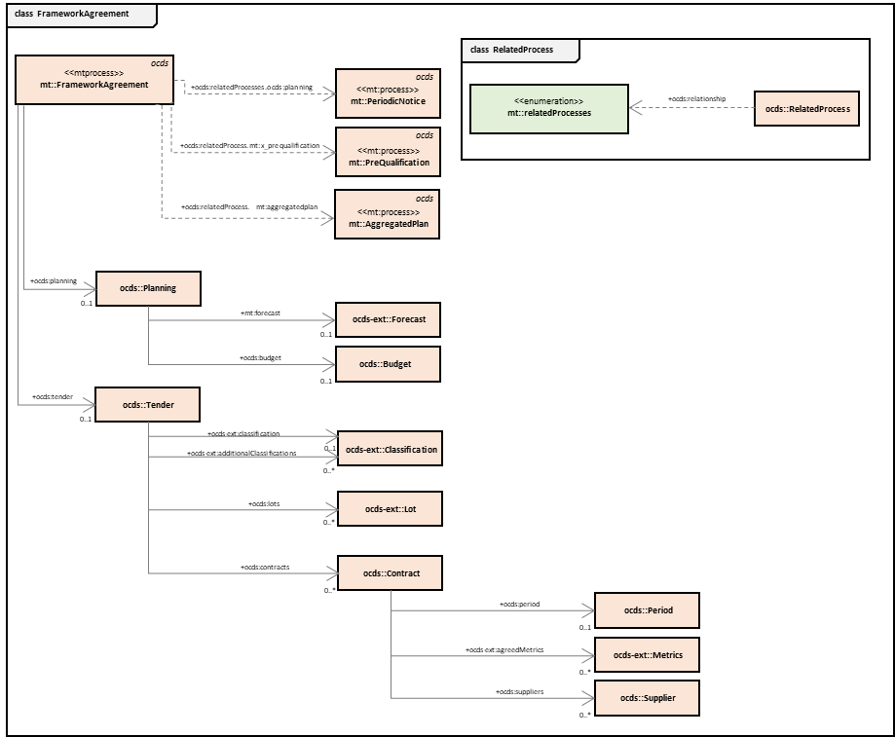

Figure 113. Framework Agreement

Class description and relationship with OCDS

The table below provides the main attributes of the “Framework Agreement” class. The “Source” column shows whether the attribute can be found in OCDS 1.1. or in an extension of OCDS (reflected as “OCDS 1.1 ext” in the “Source” column). In the “Comments” column, a link to the OCDS object description is provided (when the attribute is an object), as well as any relevant comment regarding the attribute.

| **Attribute** | **Source** | **Description** | **Type** | **Comments** |
| --- | --- | --- | --- | --- |
| Ocid | OCDS 1.1 | Global unique identifier for this FA | String | The Open Contracting ID (ocid) is a globally unique identifier for a contracting process. Every OCDS release has an ocid. |
| Planning | OCDS 1.1 | The planning of this FA | Planning | <https://standard.open-contracting.org/1.1/en/schema/reference/?highlight=planning#planning> |
| forecast | OCDS 1.1 ext | The indicative scope of this FA | Metric | <https://github.com/open-contracting-extensions/ocds_metrics_extension> |
| budget | OCDS 1.1 ext | The indicative budget for this FA | Budget | <https://github.com/open-contracting-extensions/ocds_budget_breakdown_extension>  Although the “budget” object is available in the OCDS 1.1 and the BudgetBreakdown is available in an extension of OCDS, the following attributes do not appear in OCDS or its extension:   * amountRequested * sourceParty (MTender attributes) |
| amount | OCDS 1.1 | Total value of the budget of the FA. | Value | <https://standard.open-contracting.org/1.1/en/schema/reference/?highlight=value#value> |
| budgetBreakdown | OCDS 1.1 ext | It is used to express a multi-source budget. | Array of BudgetBreakdown | <https://github.com/open-contracting-extensions/ocds_budget_breakdown_extension> |
| tender | OCDS 1.1 | Tender related to the FA | Tender | <https://standard.open-contracting.org/1.1/en/schema/reference/tender#tender> |
| title | OCDS 1.1 | Title for FA | Text | <https://standard.open-contracting.org/1.1/en/schema/reference/tender#tender> |
| description | OCDS 1.1 | Description for FA | Text | <https://standard.open-contracting.org/1.1/en/schema/reference/tender#tender> |
| value | OCDS 1.1 | Indicative value of this FA | Value | https://standard.open-contracting.org/latest/en/schema/reference/#value |
| mainProcurementCategory | OCDS 1.1 | Main procurement category of this FA | Text | <https://standard.open-contracting.org/1.1/en/schema/reference/tender#tender> |
| contractPeriod | OCDS 1.1 | Indicative duration of this FA | Period | <https://standard.open-contracting.org/1.1/en/schema/reference/#period> |
| contracts | OCDS 1.1 | List of contracts concluded under this FA | Array of contracts | <https://standard.open-contracting.org/latest/en/schema/reference/#contract> |
| period | OCDS1.1 | Indicative duration of this contract | Period | <https://standard.open-contracting.org/1.1/en/schema/reference/?highlight=OrganizationReference#period> |
| agreedMetrics | OCDS 1.1 ext | Any target metrics set out as part of the contract documents. | Metrics | https://github.com/open-contracting-extensions/ocds_metrics_extension |
| suppliers | OCDS 1.1 ext | The suppliers explicitly named in this contract | Array of OrganizationReference | <https://extensions.open-contracting.org/en/extensions/contract_suppliers/>  <https://standard.open-contracting.org/1.1/en/schema/reference/#organizationreference> |
| relatedProcess | OCDS1.1 | List of the parallel processes related to this FA | RelatedProcess | https://standard.open-contracting.org/latest/en/schema/reference/?highlight=relatedProcess#relatedprocess |
| *.relationship: x_demand | OCDS1.1 | Link to PNs | RelatedProcess | https://standard.open-contracting.org/latest/en/schema/reference/?highlight=relatedProcess#relatedprocess |
| *.relationship: planning | OCDS1.1 | Link to AP | RelatedProcess | https://standard.open-contracting.org/latest/en/schema/reference/?highlight=relatedProcess#relatedprocess |

Table 20. Attributes of the “Framework Agreement” class

## Funding Source

“Funding Source” is a stream describing a specific source of funding for procurement of goods, services or works from a parent Expenditure Item. It contains information on both the amount and the organization that provides the funds, as well as on the parties involved in the disposal of these funds such as payer, donor, etc. This class does not exist as a structured block in OCDS 1.1 or its extensions, but it is needed for the management of framework agreements.

Diagram

The diagram below shows the structure for “Funding Source” class, represented as a class diagram:

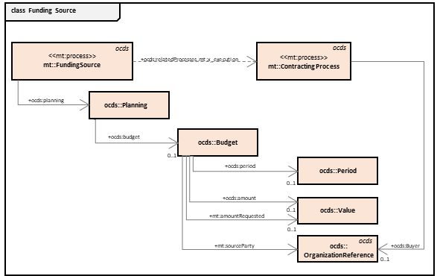

Figure 114. Funding Source

Class description and relationship with OCDS

Funding source does not appear as an OCDS concept, but its attributes and concepts are described in the OCDS structure.

The table below provides the attributes of the “Funding Source” class. The “Source” column reflects whether the attribute can be found in OCDS 1.1. or in an extension of OCDS (reflected as “OCDS 1.1 ext” in the “Source” column). In the “Comments” column, a link to the OCDS object description is provided (when the attribute is an object), as well as any relevant comment regarding the attribute.

| **Attribute** | **Source** | **Description** | **Type** | **Comments** |
| --- | --- | --- | --- | --- |
| ocid | OCDS 1.1 | Global unique identifier for this funding source | String | An Open Contracting ID (ocid) is a globally unique identifier for a contracting process. Every OCDS release has an ocid. |
| planning | OCDS 1.1 | Plan related to the Funding Source | Planning | <https://standard.open-contracting.org/1.1/en/schema/reference/?highlight=planning#planning> |
| budget | OCDS 1.1 ext | Detailed information about this funding source. | Budget | <https://github.com/open-contracting-extensions/ocds_budget_breakdown_extension>  Although the “budget” object is available in the OCDS 1.1 and the BudgetBreakdown is available in an extension of OCDS, the following attributes do not appear in OCDS or its extension:   * amountRequested * sourceParty (MTender attributes) |
| status |  | Future steps of representing the workflow of budget approvals | Code | This attribute does not appear in OCDS 1.1, nor in any extension, but it’s being discussed in Issue #616:  <https://github.com/open-contracting/standard/issues/616>  This attribute is necessary for the data model, and it will probably be added to the standard. |
| period | OCDS1.1 | The period of availability of this funding source | Period | <https://standard.open-contracting.org/1.1/en/schema/reference/?highlight=OrganizationReference#period> |
| amountRequested | OCDS 1.1 | Future steps of representing the workflow of budget approvals | Value | https://github.com/open-contracting/standard/issues/616 |
| amount | OCDS 1.1 | The absolute value of this funding source | Value | <https://standard.open-contracting.org/1.1/en/schema/reference/?highlight=value#value> |
| sourceParty | OCDS 1.1 ext | The organization related to this funding source | OrganizationReference | <https://github.com/open-contracting-extensions/ocds_budget_breakdown_extension> |
| relatedProcess | OCDS 1.1 | The link to an Expenditure Item this FS is related to | RelatedProcess | https://standard.open-contracting.org/latest/en/schema/reference/?highlight=relatedProcess#relatedprocess |

Table 21. Attributes of the “Funding Source” class

## Expenditure item

“Expenditure Item” is a stream describing a group of goods, services or works that a Contracting Authority plans to procure over a certain period, as well as the amount available for the Contracting Authority (as a sum of all the Funding Sources identified for this Expenditure Item as child elements) to cover the purchases of subject of this group during the specified period. This class does not exist as a structured block in OCDS 1.1 or its extensions, but it is needed for framework agreements.

Diagram

The diagram below shows the structure for “Expenditure Item” class, represented as a class diagram:

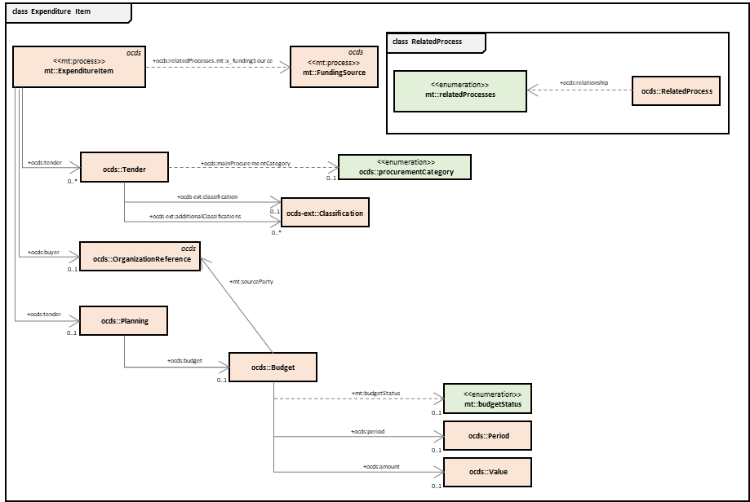

Figure 115. Expenditure Item

Class description and relationship with OCDS

The table below provides the attributes of the “Expenditure item” class. The “Source” column reflects whether the attribute can be found in OCDS 1.1. or in an extension of OCDS (reflected as “OCDS 1.1 ext” in the “Source” column). In the “Comments” column, a link to the OCDS object description is provided (when the attribute is an object), as well as any relevant comment regarding the attribute.

| **Attribute** | **Source** | **Descriptio** | **Type** | **Comments** |
| --- | --- | --- | --- | --- |
| ocid | OCDS 1.1 | Global unique identifier for this expenditure item | String | An Open Contracting ID (ocid) is a globally unique identifier for a contracting process. Every OCDS release has an ocid. |
| tender | OCDS 1.1 | Tender with the information for this EI | Tender | <https://standard.open-contracting.org/1.1/en/schema/reference/?highlight=tender#tender> |
| mainProcurementeCategory | OCDS 1.1 | Category of the subject of this expenditure item | Code |  |
| classification |  | CPV classification of the subject of this expenditure item | Text | Not covered by OCDS 1.1  https://extensions.open-contracting.org/en/extensions/tenderClassification/master/schema/#tender |
| buyer | OCDS 1.1 | Organization in whose interests the need is declared | OrganizationReference | <https://standard.open-contracting.org/latest/en/schema/reference/#organizationreference> |
| planning | OCDS 1.1 | Planning with the budget information under this EI | Planning | <https://standard.open-contracting.org/1.1/en/schema/reference/?highlight=planning#planning> |
| budget | OCDS 1.1 ext | Budget under this EI | Budget | <https://github.com/open-contracting-extensions/ocds_budget_breakdown_extension>  Although the “budget” object is available in the OCDS 1.1 and the BudgetBreakdown is available in an extension of OCDS, the following attributes do not appear in OCDS or its extension:   * amountRequested * sourceParty (MTender attributes) |
| period | OCDS1.1 | The aggregated period of availability of funding sources under this expenditure item | Period | <https://standard.open-contracting.org/1.1/en/schema/reference/?highlight=OrganizationReference#period> |
| amount | OCDS 1.1 | The absolute total value of all the funding sources under this expenditure item | Value | <https://standard.open-contracting.org/1.1/en/schema/reference/?highlight=value#value> |
| relatedProcess | OCDS 1.1 | The link to the funding sources allocated for this expenditure item | Array of RelatedProcess | https://standard.open-contracting.org/latest/en/schema/reference/?highlight=relatedProcess#relatedprocess |

Table 22. Attributes of the “Expenditure item” class

## Contracting process

“Contracting Process” is a stream describing a specific general initiation started by Contract Authority in order to satisfy related expenditure item or its part. This class describes a process, so it does not match with an OCDS block. However, it is needed in the framework agreement data model in order to store all the planning and tender information, and its relationship with other processes.

Diagram

The diagram below shows the structure for “Contracting Process” class, represented as a class diagram:

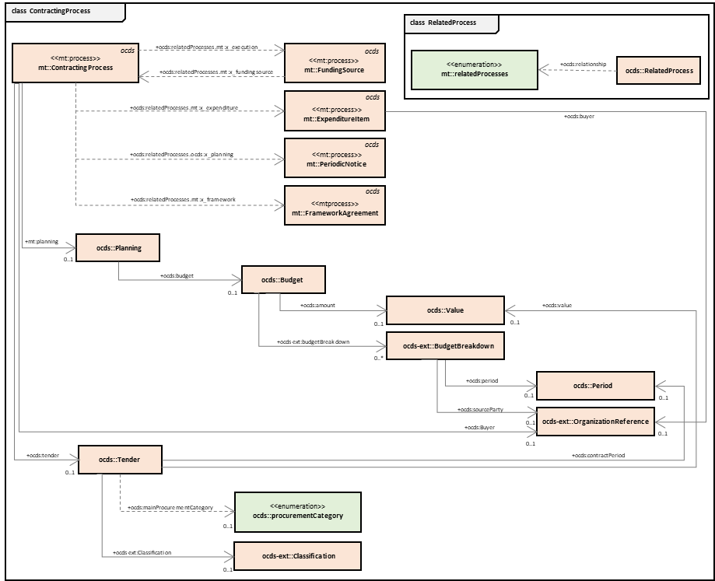

Figure 116. Contracting process

Class description and relationship with OCDS

The table below provides the attributes of the “Contracting process” class. The “Source” column reflects whether the attribute can be found in OCDS 1.1. or in an extension of OCDS (reflected as “OCDS 1.1 ext” in the “Source” column). In the “Comments” column, a link to the OCDS object description is provided (when the attribute is an object), as well as any relevant comment regarding the attribute.

| **Attribute** | **Source** | **Description** | **Type** | **Comments** |
| --- | --- | --- | --- | --- |
| ocid | OCDS 1.1 | Global unique identifier for this Contracting Process | String | An Open Contracting ID (ocid) is a globally unique identifier for a contracting process. Every OCDS release has an ocid. |
| planning | OCDS 1.1 | Planning related to the Contracting Process | Planning | <https://standard.open-contracting.org/1.1/en/schema/reference/?highlight=planning#planning> |
| budget | OCDS 1.1 ext | Detailed budget under this procurement process | Budget | <https://github.com/open-contracting-extensions/ocds_budget_breakdown_extension>  Although the “budget” object is available in the OCDS 1.1 and the BudgetBreakdown is available in an extension of OCDS, the following attributes do not appear in OCDS or its extension:   * amountRequested * sourceParty (MTender attributes) |
| amount | OCDS 1.1 | The overall value of the funds allocated for this contacting process | Value | <https://standard.open-contracting.org/1.1/en/schema/reference/?highlight=value#value> |
| budgetBreakdown | OCDS 1.1 ext | Detailed budget breakdown under this contracting process, covering multiple budget funding and multiple periods | BudgetBreakdown | https://github.com/open-contracting-extensions/ocds_budget_breakdown_extension/blob/master/release-schema.json |
| ocid | OCDS 1.1 | budgetBreakdown identifier | String | An Open Contracting ID (ocid) is a globally unique identifier for a contracting process. Every OCDS release has an ocid. |
| amount | OCDS 1.1 | budgetBreakdown amount | Value | <https://standard.open-contracting.org/1.1/en/schema/reference/?highlight=value#value> |
| period | OCDS1.1 | budgetBreakdown period | Period | <https://standard.open-contracting.org/1.1/en/schema/reference/#period> |
| sourceParty | OCDS1.1 | budgetBreakdown source party | OrganizationReference | <https://standard.open-contracting.org/latest/en/schema/reference/#organizationreference> |
| tender | OCDS 1.1 ext | Tender to store the CP information | Tender | <https://standard.open-contracting.org/1.1/en/schema/reference/?highlight=tender#tender> |
| title | OCDS 1.1 | An overall title for this contracting process | Text | <https://standard.open-contracting.org/latest/en/schema/reference/#tender> |
| description | OCDS 1.1 | An overall description for this contracting process | Text | <https://standard.open-contracting.org/latest/en/schema/reference/#tender> |
| value | OCDS 1.1 | The total upper estimated value of the contracting process | Value | <https://standard.open-contracting.org/1.1/en/schema/reference/?highlight=value#value> |
| mainProcurementCatergory | OCDS 1.1 | Category of the subject of this contracting process | Code | https://standard.open-contracting.org/latest/en/schema/codelists/#procurement-category |
| contractPeriod | OCDS 1.1 | The period over which the contract is estimated or required to be active | Period | <https://standard.open-contracting.org/1.1/en/schema/reference/?highlight=OrganizationReference#period> |
| classification |  | CPV classification of the subject of this expenditure item | Text | Not covered.  https://extensions.open-contracting.org/en/extensions/tenderClassification/master/schema/#tender |
| buyer | OCDS 1.1 | Organization in whose interests the need is declared | OrganizationReference | [https://standard.open-contracting.org/latest/en/schema/reference/#organizationreference](https://standard.open-contracting.org/latest/en/schema/reference/%23organizationreference) |
| relatedProcesses | OCDS 1.1 | Parallel processes related to a current one | Array of RelatedProcess | https://standard.open-contracting.org/latest/en/schema/reference/?highlight=relatedProcess#relatedprocess |
| *.relationship: x_fundingSource | OCDS 1.1 | Link to related FS(s) | Array of RelatedProcess | https://standard.open-contracting.org/latest/en/schema/reference/#relatedprocess |
| *.relationship: x_expenditure | OCDS 1.1 | Link to related EI(s) | Array of RelatedProcess | https://standard.open-contracting.org/latest/en/schema/reference/#relatedprocess |
| *.relationship: planning | OCDS 1.1 | Link to related PN | RelatedProcess | https://standard.open-contracting.org/latest/en/schema/reference/#relatedprocess |
| *.relationship: x_framework | OCDS 1.1 | Where subject is included in FA - link to related FA | RelatedProcess | https://standard.open-contracting.org/latest/en/schema/reference/#relatedprocess |

Table 23. Attributes of the “Contracting process” class

## Periodic notice

“Periodic notice” is a stream announcing an intention to conduct a tender. It describes an announcement of the intention of the Contracting Authority to conduct a procurement procedure.

This class does not exist as a structured block in OCDS 1.1 or its extensions, but it is needed for the management of framework agreements.

Diagram

The diagram below shows the structure for “Periodic notice” class, represented as a class diagram:

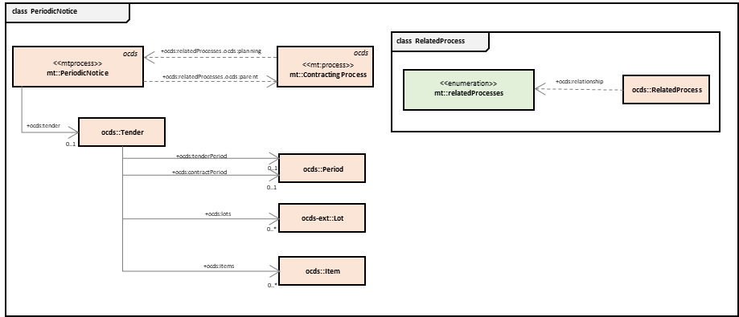

Figure 117. Periodic notice

Class description and relationship with OCDS

The table below provides the attributes of the “Periodic notice” class. The “Source” column reflects whether the attribute can be found in OCDS 1.1. or in an extension of OCDS (reflected as “OCDS 1.1 ext” in the “Source” column). In the “Comments” column, a link to the OCDS object description is provided (when the attribute is an object), as well as any relevant comment regarding the attribute.

| **Attribute** | **Source** | **Description** | **Type** | **Comments** |
| --- | --- | --- | --- | --- |
| ocid | OCDS 1.1 | Global unique identifier for the PN under this Contracting Process | String | An Open Contracting ID (ocid) is a globally unique identifier for a contracting process. Every OCDS release has an ocid. |
| tender | OCDS 1.1 | Tender related to this contracting process | Tender | <https://standard.open-contracting.org/1.1/en/schema/reference/#tender> |
| tenderPeriod | OCDS1.1 | Indicative date (month or quarter) of call for proposals under this contracting process | Period | <https://standard.open-contracting.org/1.1/en/schema/reference/#period> |
| contractPeriod | OCDS1.1 | Expected contract period for a contract concluded under this contracting process | Period | <https://standard.open-contracting.org/1.1/en/schema/reference/#period> |
| lots | OCDS 1.1 ext | Provisional division into lots of a subject of procurement | Array of Lots | <https://github.com/open-contracting-extensions/ocds_lots_extension> |
| items | OCDS 1.1 | Provisional nomenclature of a subject of procurement | Array of Item | <https://standard.open-contracting.org/latest/en/schema/reference/#item> |
| relatedProcess | OCDS 1.1 | Link to the parent contracting process | RelatedProcess | The link to an Expenditure Item this Funding Source is related to  https://standard.open-contracting.org/latest/en/schema/reference/?highlight=relatedProcess#relatedprocess |

Table 24. Attributes of the “Periodic notice” class

## Mini Competition

“Mini competition” describes a simplified competitive procurement process by the Contracting Authority under the framework agreement.

This class describes a process so it does not match with an OCDS block. However, it is needed in the framework agreement data model in order to store all the planning and tender information, and its relationship with other processes.

Diagram

The diagram below shows the structure for “Mini Competition” class, represented as a class diagram:

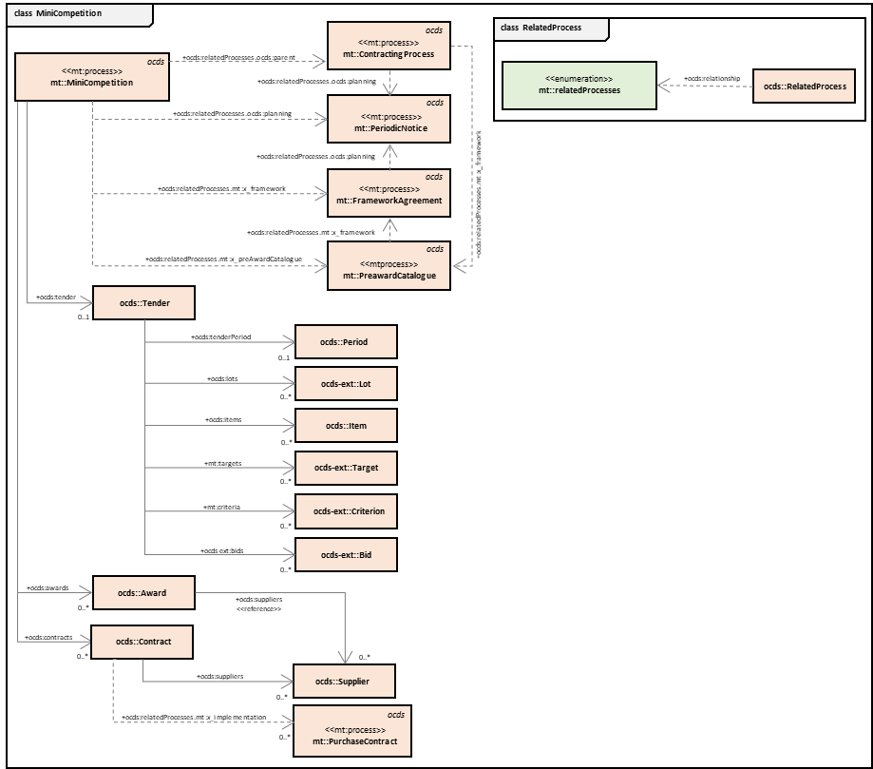

Figure 118. Mini Competition

Class description and relationship with OCDS

The table below provides the attributes of the “Mini Competition” class. The “Source” column reflects whether the attribute can be found in OCDS 1.1. or in an extension of OCDS (reflected as “OCDS 1.1 ext” in the “Source” column). In the “Comments” column, a link to the OCDS object description is provided (when the attribute is an object), as well as any relevant comment regarding the attribute.

| **Attribute** | **Source** | **Description** | **Type** | **Comments** |
| --- | --- | --- | --- | --- |
| ocid | OCDS 1.1 | Global unique identifier for the MC under this Contracting Process | String | An Open Contracting ID (ocid) is a globally unique identifier for a contracting process. Every OCDS release has an ocid. |
| tender | OCDS 1.1 ext | Tender object to store MC information | Tender | <https://standard.open-contracting.org/1.1/en/schema/reference/?highlight=tender#tender> |
| tenderPeriod | OCDS 1.1 | Period for submitting a bids in this mini-competition | Period | <https://standard.open-contracting.org/1.1/en/schema/reference/?highlight=OrganizationReference#period> |
| lots | OCDS 1.1 ext | Lots of this mini-competition | Array of Lots | <https://github.com/open-contracting-extensions/ocds_lots_extension> |
| items | OCDS 1.1 | Nomenclature of this mini-competition | Array of Item | <https://standard.open-contracting.org/latest/en/schema/reference/#item> |
| targets | OCDS 1.1 ext | Any indicative metrics criteria applied for this mini-competition | Array of Item | https://github.com/open-contracting-extensions/ocds_metrics_extension |
| criteria | OCDS 1.1 ext | Any evaluation criteria applied for this mini-competition | Array of Criteria | https://github.com/open-contracting-extensions/ocds_requirements_extension |
| bids | OCDS 1.1 ext | List of bids collected under this mini-competition | Array of Bids | https://github.com/open-contracting-extensions/ocds_bid_extension |
| awards | OCDS 1.1 | List of award-decision taken under this mini-competition | Array of Awards | <https://standard.open-contracting.org/latest/en/schema/reference/#award> |
| contracts | OCDS 1.1 |  | Array of Contracts | <https://standard.open-contracting.org/latest/en/schema/reference/#contract> |
| supplier | OCDS 1.1 ext | List of suppliers awarded under this mini-competition | Array of Suppliers | <https://standard.open-contracting.org/1.1/en/schema/reference/#organizationreference> |
| AwardID | OCDS 1.1 ext | Reference on award for purchase contract concluded under this MC | Text |  |
| relatedProcess | OCDS 1.1 | Parallel processes related to a current one | RelatedProcess | https://standard.open-contracting.org/latest/en/schema/reference/?highlight=relatedProcess#relatedprocess |
| *.relationship: parent | OCDS 1.1 | Link to a CP | RelatedProcess | https://standard.open-contracting.org/latest/en/schema/reference/?highlight=relatedProcess#relatedprocess |
| *.relationship: planning | OCDS 1.1 | Link to PN | RelatedProcess | https://standard.open-contracting.org/latest/en/schema/reference/?highlight=relatedProcess#relatedprocess |
| *.relationship: framework | OCDS 1.1 | Link to FA | RelatedProcess | https://standard.open-contracting.org/latest/en/schema/reference/?highlight=relatedProcess#relatedprocess |
| *.relationship: x_preAwardCatalogue | OCDS 1.1 | Link to PcR | RelatedProcess | https://standard.open-contracting.org/latest/en/schema/reference/?highlight=relatedProcess#relatedprocess |

Table 25. Attributes of the “Mini Competition” class

## Purchase contract

“Purchase Contract” describes a contract concluded within this framework agreement via one of the applicable methods allowed under the execution of a framework agreement.

This class expands the OCDS “Contract” block. It is based on it and needed in the framework agreement data model in order to store all information, and its relationship with other processes.

Diagram

The diagram below shows the structure for “Purchase contract” class, represented as a class diagram:

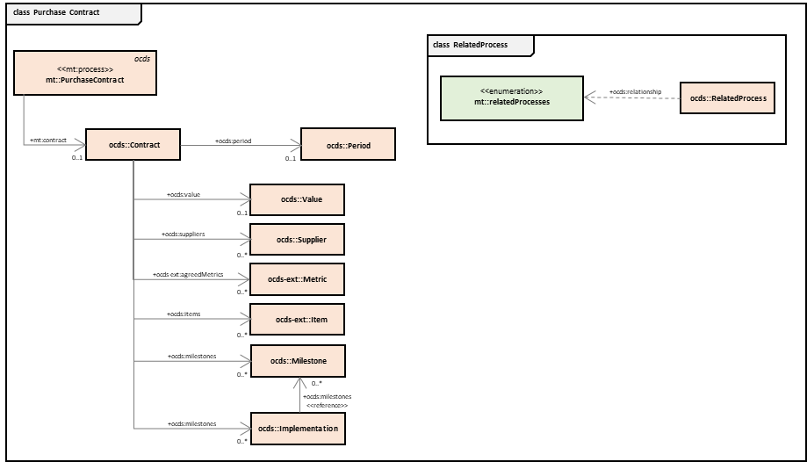

Figure 119. Purchase Contract

Class description and relationship with OCDS

The table below provides the attributes of the “Purchase contract” class. The “Source” column reflects whether the attribute can be found in OCDS 1.1. or in an extension of OCDS (reflected as “OCDS 1.1 ext” in the “Source” column). In the “Comments” column, a link to the OCDS object description is provided (when the attribute is an object), as well as any relevant comment regarding the attribute.

| **Attribute** | **Source** | **Description** | **Type** | **Comments** |
| --- | --- | --- | --- | --- |
| ocid | OCDS 1.1 | Global unique identifier for the PC under this Contracting Process | String | An Open Contracting ID (ocid) is a globally unique identifier for a contracting process. Every OCDS release has an ocid. |
| contracts | OCDS 1.1 | Information about the contract | Array of Contracts | <https://standard.open-contracting.org/latest/en/schema/reference/#contract> |
| contractPeriod | OCDS 1.1 | A period for this PC | Period | [https://standard.open-contracting.org/1.1/en/schema/reference/#period](https://standard.open-contracting.org/1.1/en/schema/reference/?highlight=OrganizationReference#period) |
| value | OCDS 1.1 | The value of this PC | Value | https://standard.open-contracting.org/1.1/en/schema/reference/#value |
| supplier | OCDS 1.1 | A supplier in this PC | Supplier | <https://standard.open-contracting.org/1.1/en/schema/reference/#organizationreference> |
| agreedMetrics | OCDS 1.1 ext | The metrics agreed under this PC | Array of Metrics | https://github.com/open-contracting-extensions/ocds_metrics_extension |
| items | OCDS 1.1 | A scope of performance under this PC | Array of Item | <https://standard.open-contracting.org/latest/en/schema/reference/#item> |
| milestones | OCDS 1.1 | The milestones of this PC | Array of Milestones | <https://standard.open-contracting.org/latest/en/schema/reference/#milestone> |
| implementation | OCDS 1.1 | An implementation record under this PC | Implementation | <https://standard.open-contracting.org/latest/en/schema/reference/#implementation> |
| relatedProcess | OCDS 1.1 |  | RelatedProcess | https://standard.open-contracting.org/latest/en/schema/reference/?highlight=relatedProcess#relatedprocess |

Table 26. Attributes of the “Purchase contract” class

## Pre-Qualification

“Purchase Contract” describes the pre-qualification phase(s) performed by the CPB for the conclusion of a framework agreement.

This class describes a block that does not match with an OCDS block. However, it is needed in the framework agreement data model in order to store all the planning, tender and contract information, and its relationship with other processes.

Diagram

The diagram below shows the structure for “Pre-Qualification” class, represented as a class diagram:

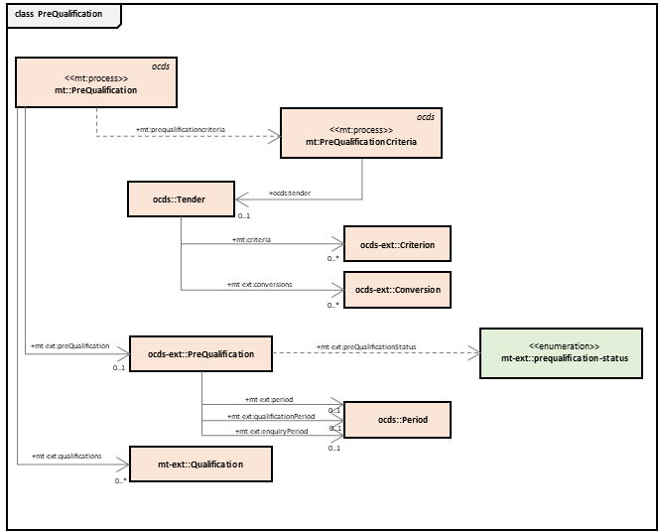

Figure 120. Pre-Qualification

Class description and relationship with OCDS

The table below provides the attributes of the “Pre-Qualification” class. The “Source” column reflects whether the attribute can be found in OCDS 1.1. or in an extension of OCDS (reflected as “OCDS 1.1 ext” in the “Source” column). In the “Comments” column, a link to the OCDS object description is provided (when the attribute is an object), as well as any relevant comment regarding the attribute.

| **Attribute** | **Source** | **Description** | **Type** | **Comments** |
| --- | --- | --- | --- | --- |
| ocid | OCDS 1.1 | Global unique identifier for the PQ under this FA | String | An Open Contracting ID (ocid) is a globally unique identifier for a contracting process. Every OCDS release has an ocid. |
| enquiryPeriod | OCDS 1.1  ext | Enquiry period allocated under this PQ | Period | <https://standard.open-contracting.org/latest/en/schema/reference/#period>  https://github.com/open-contracting-extensions/ocds_qualification_extension |
| period | OCDS 1.1 | Period for submission of EoIs | Period | <https://standard.open-contracting.org/latest/en/schema/reference/#period>  <https://standard.open-contracting.org/latest/en/schema/reference/#period>  https://github.com/open-contracting-extensions/ocds_qualification_extension |
| qualificationPeriod | OCDS 1.1 | Period for consideration of EoIs collected by PE | Period | <https://standard.open-contracting.org/latest/en/schema/reference/#period>  <https://standard.open-contracting.org/latest/en/schema/reference/#period>  https://github.com/open-contracting-extensions/ocds_qualification_extension |
| submissions | Not covered | EoIs by interested EOs | Array of Submission | This attribute does not appear in OCDS 1.1, nor in any extension. |
| qualifications | Not covered | Qualification decisions by PE against received EoI | Array of Qualification | This attribute does not appear in OCDS 1.1, nor in any extension. |

Table 27. Attributes of the “Pre-Qualification” class

## Pre-Award Catalogue

“Pre-Award Catalogue” describes a structured electronic catalogue with specific categories of goods or services for this Framework Agreement and the relevant indicative prices received from selected suppliers.

This class does not match with an OCDS block. However, it is needed in the framework agreement data model in order to store all the planning, tender and contract information, and its relationship with other processes.

Diagram

The diagram below shows the structure for “Pre-Award Catalogue” class, represented as a class diagram:

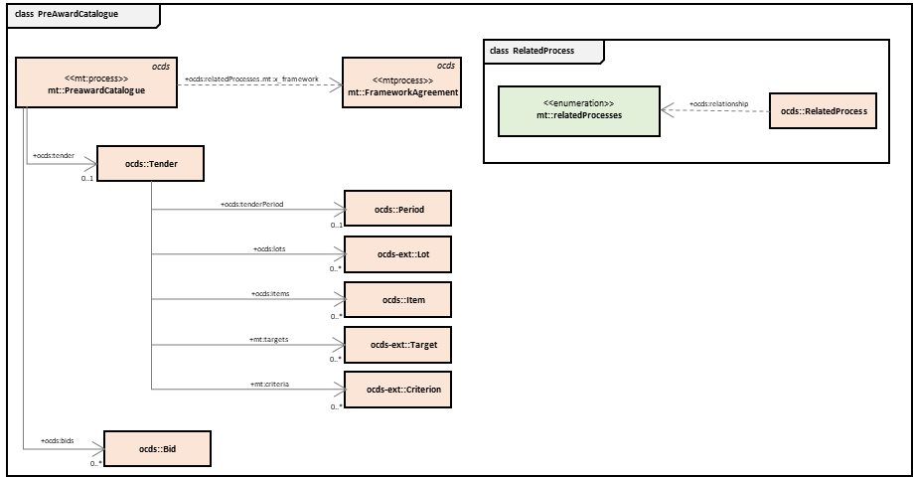

Figure 121. Pre-Award Catalogue

Class description and relationship with OCDS

The table below provides the attributes of the “Pre-Award Catalogue” class. The “Source” column reflects whether the attribute can be found in OCDS 1.1. or in an extension of OCDS (reflected as “OCDS 1.1 ext” in the “Source” column). In the “Comments” column, a link to the OCDS object description is provided (when the attribute is an object), as well as any relevant comment regarding the attribute.

| **Attribute** | **Source** | **Description** | **Type** | **Comments** |
| --- | --- | --- | --- | --- |
| ocid | OCDS 1.1 | Global unique identifier for the PaC under this FA | String | An Open Contracting ID (ocid) is a globally unique identifier for a contracting process. Every OCDS release has an ocid. |
| tender | OCDS 1.1 ext | Tender class to store the information | Tender | <https://standard.open-contracting.org/1.1/en/schema/reference/?highlight=tender#tender> |
| lots | OCDS 1.1 ext | List of lots that can be divided the PaC. | Array of Lots | <https://github.com/open-contracting-extensions/ocds_lots_extension> |
| items | OCDS 1.1 | Nomenclature requested by PE within PcR | Array of Item | <https://standard.open-contracting.org/latest/en/schema/reference/#item> |
| targets | OCDS 1.1 ext | Any targets indicated by PE within PcR | Array of Metric | https://github.com/open-contracting-extensions/ocds_metrics_extension |
| criteria | OCDS 1.1 ext | Evaluation criteria related to a nomenclature requested by this PcR | Array of Criteria | https://github.com/open-contracting-extensions/ocds_requirements_extension |
| tenderPeriod | OCDS 1.1 | Period for submission of pre-award catalogues by invited EOs | Period | <https://standard.open-contracting.org/latest/en/schema/reference/#period> |
| bids | OCDS 1.1 ext | Pre-award catalogues submitted by invited EOs | Array of Bids | https://github.com/open-contracting-extensions/ocds_bid_extension |
| relatedProcess | OCDS 1.1 |  | RelatedProcess | https://standard.open-contracting.org/latest/en/schema/reference/?highlight=relatedProcess#relatedprocess |
| *.relationship: framework | OCDS 1.1 | Link to FA | RelatedProcess | https://standard.open-contracting.org/latest/en/schema/reference/?highlight=relatedProcess#relatedprocess |

Table 28. Attributes of the “Pre-Award Catalogue” class

## Aggregated Plan

“Aggregated Plan” describes both aggregated demand and budget as per CPB analysis.

This class does not match with an OCDS block. However, it is needed in the framework agreement data model in order to store all the planning, tender and contract information, and its relationship with other processes.

The “Aggregated Plan” class is described in the “Framework Agreement” diagram, as their attributes are contained within the Framework Agreement and Tender structure. The two classes “Framework Agreement” and “Aggregated Plan” are divided in two different table descriptions for a more detailed understanding, as shown in *Figure 113. Framework Agreement* in section 5.1.

Class description and relationship with OCDS

The table below provides the attributes of the “Aggregated Plan” class. The “Source” column reflects whether the attribute can be found in OCDS 1.1. or in an extension of OCDS (reflected as “OCDS 1.1 ext” in the “Source” column). In the “Comments” column, a link to the OCDS object description is provided (when the attribute is an object), as well as any relevant comment regarding the attribute.

| **Attribute** | **Source** | **Description** | **Type** | **Comments** |
| --- | --- | --- | --- | --- |
| ocid | OCDS 1.1 | Global unique identifier for the AP under this FA | String | An Open Contracting ID (ocid) is a globally unique identifier for a contracting process. Every OCDS release has an ocid. |
| tender | OCDS 1.1 | Tender object to store the AP indormation | Tender | <https://standard.open-contracting.org/1.1/en/schema/reference/?highlight=tender#tender> |
| classification | OCDS 1.1 | Classification of this FA according to CPV | Classification | https://standard.open-contracting.org/latest/en/schema/reference/#classification |
| tenderPeriod | OCDS 1.1 | Indicative date of start of FA establishment | Period | <https://standard.open-contracting.org/latest/en/schema/reference/#period> |
| items | OCDS 1.1 | Nomenclature of this AP | Array of Item | <https://standard.open-contracting.org/latest/en/schema/reference/#item> |
| lots | OCDS 1.1 ext | Lots of this AP | Array of Lots | <https://github.com/open-contracting-extensions/ocds_lots_extension> |
| relatedProcess | OCDS 1.1 | Parallel processes related to this AP | RelatedProcess | https://standard.open-contracting.org/latest/en/schema/reference/?highlight=relatedProcess#relatedprocess |
| *.relationship: x_scope | OCDS 1.1 | Link to PNs | RelatedProcess | https://standard.open-contracting.org/latest/en/schema/reference/?highlight=relatedProcess#relatedprocess |
| *.relationship: parent | OCDS 1.1 | Link to FA | RelatedProcess | https://standard.open-contracting.org/latest/en/schema/reference/?highlight=relatedProcess#relatedprocess |

Table 29. Attributes of the “Aggregated Plan” class

## Framework Establishment

“Framework Establishment” describes the establishing of this framework agreement, with all the necessary elements for the conclusion of the framework agreement.

This class describes a process, so it does not match with an OCDS block. However, it is needed in the framework agreement data model in order to store all the planning, tender and framework information, and its relationship with other processes.

The “Framework Establishment” class is described within the “Framework Agreement” diagram, as their attributes are contained in the Framework Agreement and Tender structure. The two classes, “Framework Agreement” and “Framework Establishment”, are divided into two different table descriptions for a more detailed understanding.

Class description and relationship with OCDS

The table below provides the attributes of the “Framework establishment” class. The “Source” column reflects whether the attribute can be found in OCDS 1.1. or in an extension of OCDS (reflected as “OCDS 1.1 ext” in the “Source” column). In the “Comments” column, a link to the OCDS object description is provided (when the attribute is an object), as well as any relevant comment regarding the attribute.

| **Attribute** | **Source** | **Description** | **Type** | **Comments** |
| --- | --- | --- | --- | --- |
| ocid | OCDS 1.1 | Global unique identifier for the FE under this FA | String | An Open Contracting ID (ocid) is a globally unique identifier for a contracting process. Every OCDS release has an ocid. |
| tender | OCDS 1.1 | Tender class to store the information in this FA | Tender | <https://standard.open-contracting.org/1.1/en/schema/reference/?highlight=tender#tender> |
| procuringEntity | OCDS 1.1 | Procuring entity in this FA | OrganizationReference | <https://standard.open-contracting.org/1.1/en/schema/reference/?highlight=tender#tender> |
| classification | OCDS 1.1 | Classification of this FA according to CPV | Classification | https://standard.open-contracting.org/latest/en/schema/reference/#classification |
| relatedProcess | OCDS 1.1 | Parallel processes related to this FE | RelatedProcess | https://standard.open-contracting.org/latest/en/schema/reference/?highlight=relatedProcess#relatedprocess |
| *.relationship: planning | OCDS 1.1 | Link to AP | RelatedProcess | https://standard.open-contracting.org/latest/en/schema/reference/?highlight=relatedProcess#relatedprocess |
| *.relationship: qualification | OCDS 1.1 | Link to PQ | RelatedProcess | https://standard.open-contracting.org/latest/en/schema/reference/?highlight=relatedProcess#relatedprocess |

Table 30. Attributes of the “Framework Establishment” class

## Pre-qualification Criteria

“Pre-qualification Criteria” describes a set of exclusion and selection criteria, together with a scoring function (if applicable), as per CPB's strategy.

This class does not match with an OCDS block. However, it is needed in the framework agreement data model in order to store all the planning, tender and qualification information, and its relationship with other processes.

The “Pre-qualification Criteria” is described within the “Pre-Qualification” diagram, as their attributes are contained within the PreQualification and Tender structures. The two classes, “PreQualification” and “Pre-qualification Criteria”, are divided into two different table descriptions for a more detailed understanding, as shown in *Figure 120. Pre-Qualification* in section 5.8.

Class description and relationship with OCDS

The table below provides the attributes of the “Pre-qualification Criteria” class. The “Source” column reflects whether the attribute can be found in OCDS 1.1. or in an extension of OCDS (reflected as “OCDS 1.1 ext” in the “Source” column). In the “Comments” column, a link to the OCDS object description is provided (when the attribute is an object), as well as any relevant comment regarding the attribute.

| **Attribute** | **Source** | **Description** | **Type** | **Comments** |
| --- | --- | --- | --- | --- |
| ocid | OCDS 1.1 | Global unique identifier for the PQC under this PQ | String | An Open Contracting ID (ocid) is a globally unique identifier for a contracting process. Every OCDS release has an ocid. |
| tender | OCDS 1.1 | Tender class to store information about this PQC | Tender | <https://standard.open-contracting.org/1.1/en/schema/reference/?highlight=tender#tender> |
| criteria | OCDS 1.1 ext | Any qualification and/or evaluation criteria to by applied by PE | Array of Criteria | https://github.com/open-contracting-extensions/ocds_requirements_extension |
| conversions |  | Any weighting related to applier criteria | Array of Conversions | Not covered by OCDS 1.1 or its extensions |
| otherCriteria | OCDS 1.1 ext | Detailed information about any other requirements or techniques by PE | Array of Criteria | https://github.com/open-contracting-extensions/ocds_otherRequirements_extension |

Table 31. Attributes of the “Pre-qualification Criteria” class

1. Definitions from UNCITRAL Model Law on Public Procurement. Access at:

   <https://www.uncitral.org/pdf/english/texts/procurem/ml-procurement-2011/2011-Model-Law-on-Public-Procurement-e.pdf>
2. <https://ec.europa.eu/environment/gpp/eu_public_directives_en.htm>
3. See further information on the eProcurement Ontology of the Publication Office of the EU:

   <https://github.com/eprocurementontology/eprocurementontology/wiki>
4. See the complete Directive 2014/24/EU:

   <https://eur-lex.europa.eu/legal-content/EN/TXT/?uri=celex%3A32014L0024>
5. See the complete diagram: <https://cawemo.com/share/4936b1c7-4467-432d-aee6-1b2cc8b3be03>
6. See the complete diagram: https://cawemo.com/share/59721d1d-458a-4af4-9af7-c9577a97b62f
7. See the complete diagram: https://cawemo.com/share/59721d1d-458a-4af4-9af7-c9577a97b62f
8. See the complete diagram: https://ebrd.huddle.net/workspace/33889435/files/#/folder/50107921/list
9. See the complete diagram: https://ebrd.huddle.net/workspace/33889435/files/#/folder/50107921/list
10. <https://app.lucidchart.com/publicSegments/view/b09729c6-cc4d-44ce-be4d-2afbe2e96195/image.png>
11. <https://app.lucidchart.com/publicSegments/view/5c214c2e-a030-4783-bace-a9731cc29018/image.png>
12. <https://cawemo.com/share/23f00821-b867-413d-b62c-eb482f34a1d6>
13. <https://cawemo.com/share/1ae8009c-d717-4ad0-aabc-f4b87337b925>